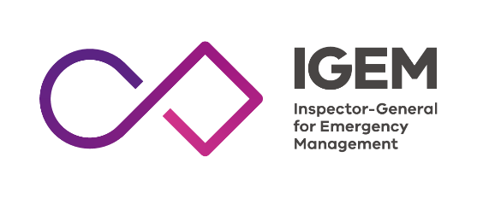
Practice statement

2021

This document will help you understand about emergency management and Victoria’s Inspector-General for Emergency Management.

What is emergency management?
Emergencies are events that can damage or destroy people, property and the environment. Emergencies include:
- floods
- bushfires
- storms
- heatwaves
- explosions
- diseases.
Emergency management means:
  - organising resources to help before, during and after an emergency
  - identifying the roles and responsibilities for dealing with emergencies
  - supporting emergency services and communities to manage emergencies the right way.
The aim of emergency management is to reduce the effects of all harmful events.

Who are we?
We are an organisation in Victoria that provides Victorians with confidence that emergency management arrangements in the state can keep communities safe.
Tony Pearce is the first Inspector-General for Emergency Management in Victoria.
Tony provides advice to the Minister for Emergency Services through his reports and reviews. His office is part of the Department of Justice and Community Safety.
Our organisation was established through the Emergency Management Act 2013 to strengthen:
- the way emergency management works before, during and after an emergency
- Victorians’ confidence in the state’s ability to prepare for, respond to, and recover from emergencies.

Why have an IGEM?
We aim to continually improve emergency management in Victoria by finding out what is working well and what could work better.
We look objectively at emergency management in Victoria and report our findings to the minister.
We see if resources and responsibilities are organised and managed effectively before, during and after emergencies.
We use this information to recommend changes that will improve Victoria’s ability to manage all aspects of emergencies.
Legally, we have the power to:
- conduct our own reviews
- ask organisations to provide us with information
- make sure improvements from reviews are put in place
- investigate performance related to Triple 000 emergency call-taking and dispatch.

What do we do?
We work with emergency management agencies and the Victorian community to strengthen and improve emergency management:
- capability
- capacity
- performance.
We use reliable and evidence-based information to understand what is working well, and where state emergency management activities can improve.
We also monitor that identified opportunities for improvement from major reviews and inquiries are put in place which makes sure that government does what it says it would do.
Finally, we help grow a culture of lasting improvement by:
- sharing what we learn
- recognising and acknowledging when things are working well
- encouraging better ways of working when we find them.

Examples of our work:
- We reviewed the 2016 thunderstorm asthma emergency and made recommendations for improvements in emergency response.
- We monitored changes introduced through the 2014 and 2015-16 Hazelwood Mine Fire inquiries and provided progress reports to the minister.
- We investigated the Triple Zero call-taking and dispatch during the 2016 thunderstorm asthma emergency
- We examined Victoria’s preparedness for, response to, and recovery from bushfires in large parts of the North East, Gippsland, and Alpine regions during 2019 and 2020.

Who do we work with?
We work with:
- emergency management agencies including state emergency service, ambulance, fire and police.
- local and state government
- industry and business
- Victorian communities.

How do we work?
We work in a way that is:
- collaborative
- evidence-based
- community focused.
We follow the four principles described in the Assurance Framework for Emergency Management:
- continuous improvement – the ongoing effort to improve over time
- collaboration and cooperation – working together and coordinating activities to increase effectiveness and efficiency
- reducing burden – respecting and minimising the amount of time and resources needed for an activity
- adding value – the difference between the benefits of a service and the cost of providing that service.

Contact IGEM
We can provide information in accessible formats including Easy English.
Phone: 03 8684 7900
Post: GPO Box 4356, Melbourne VIC 3001
Email: igem@igem.vic.gov.au
Address: 121 Exhibition Street, Melbourne VIC 3000
Twitter: @IGEM_Vic
Facebook: @IGEMVictoria
Website: igem.vic.gov.au

