Review of incident management teams: accreditation and rostering

ii

Authorised and published by the Victorian Government, 1 Treasury Place, Melbourne. July 2017
ISBN 978-1-925549-42-3 (Print)
ISBN 978-1-925549-43-0 (pdf/online)

© State of Victoria 2017

Unless indicated otherwise, this work is made available under the terms of the Creative Commons Attribution 3.0 Australia licence. To view a copy of this licence, visit creativecommons.org/licenses/by/3.0/au

It is a condition of this Creative Commons Attribution 3.0 Licence that you must give credit to the original author who is the
State of Victoria.

If you would like to receive this publication in an alternative format telephone (03) 8684 7900 or email igem@justice.vic.gov.au

Inspector-General for Emergency Management
Department of Justice and Regulation
GPO Box 4356, Melbourne Victoria 3001
Telephone: (03) 8684 7900
Email: igem@justice.vic.gov.au

This publication is available in PDF and Word format on www.igem.vic.gov.au

Review of incident management teams: accreditation and rostering iii

Contents

Executive summary........................................................................................................................................................ 1

2 Introduction..................................................................................................................................................... 5

2.1 Objective of the review ..................................................................................................................................... 6

2.2 Scope of the review .......................................................................................................................................... 6

2.3 Structure of the report....................................................................................................................................... 6

2.4 Stakeholders..................................................................................................................................................... 6

2.5 Approach .......................................................................................................................................................... 6

2.6 Terminology...................................................................................................................................................... 7

2.7 Acknowledgements .......................................................................................................................................... 7

3 Background..................................................................................................................................................... 8

3.1 Incident management in Victoria ...................................................................................................................... 8

3.2 Developing a Level 3 IMT training and accreditation model ........................................................................... 12

3.3 Rostering and deploying IMT personnel ......................................................................................................... 14

4 Developing IMT capability and capacity ..................................................................................................... 19

4.1 Pathway and services for IMT capability development ................................................................................... 19

4.2 Managing and resourcing IMT capability development................................................................................... 23

4.3 Planning and coordinating IMT capability and capacity development............................................................. 26

5 Operating an IMT .......................................................................................................................................... 32

5.1 Resourcing an IMT ......................................................................................................................................... 32

5.2 Effectiveness of regional IMT capability and capacity .................................................................................... 34

5.3 Coordinating IMT capability ............................................................................................................................ 37

6 Concluding remarks ..................................................................................................................................... 41

7 References .................................................................................................................................................... 42

iv

Acronyms

AIIMS | Australasian Inter-service Incident Management System
CFA | Country Fire Authority
DELWP | Department of Environment, Land, Water and Planning
DSE | Department of Sustainability and Environment
EMC | Emergency Management Commissioner
EMV | Emergency Management Victoria
IC | Incident Controller
ICC | Incident Control Centre
IGEM | Inspector-General for Emergency Management
IMT | Incident Management Team
IMTTP | Incident Management Team Training Project
JSOP | Joint Standard Operating Procedure
MFB | Metropolitan Fire and Emergency Services Board
NIFC | National Interagency Fire Centre
OT&V | Occupational Training and Volunteerism
RC | Regional Controller
SCRC | State Crisis and Resilience Council
SERP | State Emergency Response Plan
SIMTDP | State-wide Incident Management Team Delivery Project
SRRS | State Resource Request System
VBRC | Victorian Bushfires Royal Commission
VICSES | Victoria State Emergency Service

Executive summary

Incident management is a core capability of an emergency management system. Incident management provides structure for the processes, decisions and actions needed to resolve an emergency incident.

In a multi-agency emergency management system, incident control directs the resources of agencies responding to incident impact and consequence. Incident control also involves works with organisations and individuals outside the formal incident management structure, and especially with communities affected by the incident.

Incident Management Teams (IMT) support Incident Controllers (IC) to manage responses to emergency incidents and their consequences. IMTs draw together personnel from responder agencies involved in managing responses to an incident, with departments, agencies and other organisations providing a range of support functions. An IMT for a large incident may number over 100 personnel.

In 2010, the Victorian Bushfires Royal Commission recommended that personnel involved in managing responses to major, or Level 3 incidents, be required to achieve a common standard of competency, and that this be implemented through a multi-agency accreditation process.

Since that time, agencies and Emergency Management Victoria (EMV) have developed and operated common training, development programs, and accreditation processes for Level 3 IMT personnel. These are based on requirements of the Australasian Inter-service Incident Management System (AIIMS).

For Level 3 IMT structures, there are established arrangements and considerable experience in managing personnel, including those developing towards Level 3 accreditation. IMT personnel are rostered in accordance with their agency practices, and IMTs are formed in readiness for summer bushfire risk. IMT operations are supported with
arrangements for supplementing personnel resources in accordance with incident demands.

Maintaining the state’s major incident management capability requires effective management of both specialised capability development, and resource management processes and arrangements. This is a complex challenge for EMV and responder agencies.

This review

The objective of this review is to assess the effectiveness of incident management arrangements in the Victorian emergency management sector, specific to role accreditation processes and approaches to the rostering of personnel into pre- planned and pre-formed IMTs.

The review focuses on AIIMS Level 3 incident management for Class 1 emergencies.

Level 3 incidents are large and complex, and are managed within a line of control comprising incident, regional and state tiers. Class 1 emergencies are those for which the Country Fire Authority (CFA), Department of Environment, Land, Water and Planning, Metropolitan Fire and Emergency Services Board and Victoria State Emergency Service are responder agencies.

Developing IMT capability and capacity

Responder agencies, with the support of EMV, have made considerable progress towards establishing a comprehensive and integrated development model for major incident management capability.

Victoria now has an established framework for personnel wishing to progress from Level 2 to Level 3 accreditation in most IMT roles. CFA, with the support of other agencies, delivered IMT training calendars from 2014 to 2016, and this will continue in 2017.

Agencies have, or are including capabilities aligned with AIIMS in their personnel capability frameworks. A multi-agency process ensures that personnel accredited at Level 3 have common standards of competency, regardless of agency. However, further work is required in a number of areas.

A sustainable resourcing and funding agreement is needed to support the accreditation pathway. The agreement should be consistent with agency responsibilities for capability, support centralised course management and delivery, and create appropriate incentives for agencies to effectively
select and manage personnel to ensure their progress to Level 3 accreditation.

Further work is required to ensure personnel seeking to progress to Level 3 accreditation have sufficient access to exercise opportunities, incident experience, and coaching or mentoring required to develop their incident management competencies.

Agencies have responsibility for selecting personnel for Level 3 development. However, there are no sector requirements to guide agency selection processes to ensure that candidates have the potential to perform in Level 3 IMT roles.
Managing IMT capability requires the state to coordinate planning and monitor the pipeline of developing Level 3 personnel to ensure numbers are sufficient to meet future incident management demands.

The reform program has not yet delivered a framework of forecast requirements for Level 3 IMT roles and personnel numbers.

In addition, there is no established process for guiding agencies on the personnel numbers needed to address gaps in Level 3 capacity.

In the absence of guidance on state requirements, and the subjective approach to selection of candidates for Level 3 accreditation, there are indications that a large number of personnel receive IMT training, but there are insufficient personnel progressing to accreditation.

The State Crisis and Resilience Council (SCRC) has initiated work to broaden the recruitment base for emergency management personnel. While a prudent response to the state’s future needs, the requirements of Level 3 accreditation may limit the number of public service employees able to make this level of contribution.

Pending establishment of state requirements for Level 3 personnel, EMV and agencies should establish multi-agency processes to manage state requirements for accredited Level 3 IMT personnel, and address constraints over the operation of the Level 3 accreditation pathway.

Operating an IMT

Senior regional managers of responder agencies all report shortages of personnel accredited for Level 3 roles. Shortages generally become acute during the summer season, although protracted incidents outside summer also challenge capacity.

Regions have limited IMT personnel, so local resources are often quickly exhausted. Recent role additions to Level 3 IMTs and the state line of control increase the personnel needed to manage incident response. Parallel resourcing of Level 3 and agency IMTs strains agency resources.

Arrangements provide for Regional Controllers (RCs) and ICs to seek further personnel first from within their own region, and with state support, from other
regions, or interstate.

However, workplace arrangements provide personnel with discretion to make themselves unavailable for IMT duty. There are also barriers to sharing Level 3
IMT workloads. These factors limit the efficiency of
Level 3 IMT capacity, and drive the administrative cost of managing Level 3 IMTs.

Identifying personnel deployment patterns would help clarify utilisation of accredited Level 3 IMT personnel and address barriers to improving efficiency. This could inform improvement of multi-agency operating policies, processes, and practices.

RCs, ICs and senior personnel play an important part in strengthening integrated operation through multi- agency relationships. Such relationships support personnel progressing to Level 3 accreditation, helping them access opportunities for coaching, exercising, and operational IMT experience.

However, senior personnel report difficulty in fulfilling the demands of their responsibilities for agency management, multi-agency collaboration, and major incident management.

Improving the efficiency of current arrangements, and strengthening the support for senior regional leadership could reduce demands on senior personnel, and support efforts to improve Level 3 IMT personnel selection and development.

Alternative Level 3 resourcing models could help address these constraints. Centrally-maintained IMTs could improve the efficiency of IMT management, and contribute to IMT skills development and
maintenance. However, the feasibility, costs and benefits of any alternative models would require careful consideration.

With the opportunity to build on groundwork already established, the issues identified in this review deserve timely consideration.
Observations and recommendations

IGEM made a number of observations throughout this review, and two recommendations.

RECOMMENDATION 1

The Inspector-General for Emergency Management recommends that the Emergency Management Commissioner, with support from Emergency Management Victoria and in collaboration with relevant agencies, continue to develop the effectiveness and sustainability of the state’s incident management capability and capacity.

Arrangements for developing and managing Incident Management Team (IMT) capability and capacity should:

• be based on an agreed long-term forecast of
IMT role and personnel requirements

• guide agencies in their organisational incident management capability planning

• identify, develop, monitor and support the progression of appropriate candidates through a common incident management accreditation pathway

• be supported by sustainable and efficient resourcing and funding (see Recommendation
2)

• monitor the utilisation of qualified and accredited personnel to improve multi-agency operating policies and practices

• continue to improve the efficiency and effectiveness of IMT and line of control structures, having regard for the feasibility, costs, and benefits of alternative models, such as pre-formed IMTs.

Under 64(1)(g) of the Emergency Management Act, the Inspector-General for Emergency Management is required to have regard to the resources that
agencies have to implement recommendations arising from system-wide reviews.

Accordingly, Recommendation 2 recognises that agencies may experience additional resource demands arising from the potential implementation of Recommendation 1, and the expected state capability plan for Level 3 IMT personnel being developed as part the emergency management reform program.

RECOMMENDATION 2

The Inspector-General for Emergency Management recommends that a sustainable funding model be developed for all levels of incident management in Victoria which:

• considers business-as-usual, agency managed response activity, and responses to major emergencies managed under the state line of control

• recognises the additional resource requirements created by plans for trained and accredited incident management personnel arising from the reform program

• accommodates personnel training and development requirements in excess of those for which responder agencies are currently funded.

Appropriately scaled and sustainable funding will enable the emergency management sector to effectively mount responses to all levels of emergency into the future.
Acknowledgements

IGEM is grateful for the participation and assistance of stakeholder organisations and their representatives who contributed to this review.

The Inspector-General particularly thanks EMV, responder agencies, and RCs who shared their experiences and perspectives, and made a valuable contribution to the information and evidence informing this review.

The willingness of representatives from the emergency management sector in providing their insight, information and evidence, affirms the sector’s commitment to working as one for continuous improvement in the state’s emergency management arrangements.

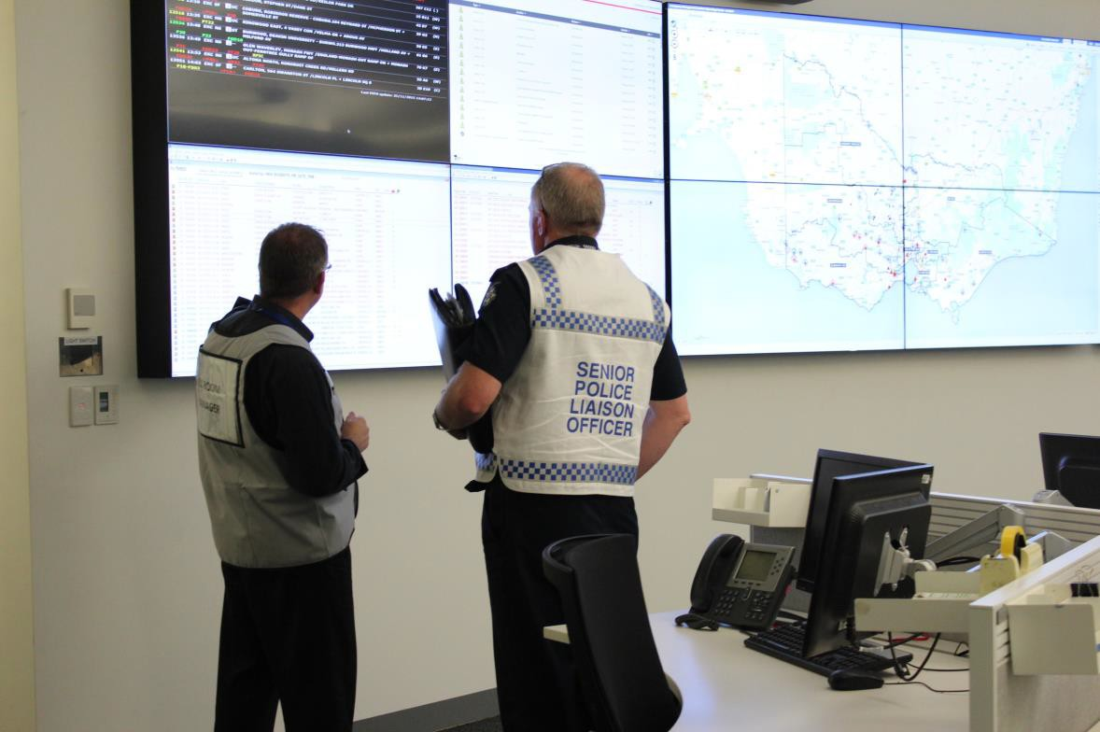

Senior police liaison officer at the State Control Centre (image courtesy Emergency Management Victoria)

2 Introduction

The Inspector-General for Emergency Management (IGEM) is a legislated appointment established under the Emergency Management Act 2013 (the Act) to:

• provide assurance to the government and the community in respect of emergency management arrangements in Victoria

• foster continuous improvement of emergency management in Victoria.

Supporting the achievement of these objectives, IGEM undertakes system-wide reviews, including reviews of the emergency management functions of responder agencies and government departments as defined in the Act.

These reviews are based on an Annual Forward Plan of Reviews developed by IGEM in consultation with the emergency management sector (the sector) and shared with the Minister for Emergency Services (the minister). In addition, IGEM may also conduct reviews at the request of the minister under the provisions of Section 64(1)(c) of the Act.

IGEM’s review of incident management teams: accreditation and rostering is a system-wide review identified in IGEM's 2016 Annual Forward Plan of Reviews. It is conducted pursuant to section 64(1)(b) of the Act.

In preparing the final report for the minister, IGEM provided draft copies to, and invited comment from, all relevant agencies to which this report relates. Comments received by IGEM from relevant agencies have been taken into account for this final report.

IGEM invites comment to meet its objective of fostering continuous improvement of emergency management in Victoria, and to meet legislative obligations contained in section 70 of the Act.

2.1 Objective of the review

The objective of this review is to assess the effectiveness of incident management arrangements in the Victorian emergency management sector, specific to role accreditation processes and approaches to the rostering of personnel into pre-
formed and pre-planned Incident Management Teams
(IMT).

2.2 Scope of the review

The review assesses the effectiveness of incident management accreditation and rostering through consideration of governance arrangements, policy, systems and practice applied to capability definition influencing:

• accreditation processes for Level 3 incident management team personnel

• rostering of Level 3 IMTs including pre-planned, pre-formed IMTs.

The review examines accreditation processes in relation to the supply of qualified personnel for Level 3
IMT roles.

The review considers only Level 3 incident management capability for Class 1 emergencies in Victoria, with a focus on response management.

The review does not consider incident management as it extends into recovery management.

The review does not evaluate the training and development program for Level 3 IMT personnel.

2.3 Structure of the report

The review outlines the background to Level 3 IMT capability development, and the current Level 3 IMT development pathway, resourcing and planning. The review then examines factors in the operational environment affecting development and management of Level 3 IMT capability and capacity.
• | Chapter 1: | Executive summary
• | Chapter 2: | Introduction
• | Chapter 3: | Background
• | Chapter 4: | Developing IMT capability and capacity
• | Chapter 5: | Operating an IMT
• | Chapter 6: | Concluding remarks
• | Chapter 7: | References

2.4 Stakeholders

The following agencies and organisations were stakeholders in this review:

• Emergency Management Victoria (EMV), which supports the Emergency Management Commissioner (EMC), coordinates development of whole-of-government policy for emergency management and implements reform initiatives.

• Responder agencies as determined in the Act, the Country Fire Authority (CFA), Department of Environment, Land, Water and Planning (DELWP), Metropolitan Fire and Emergency Services Board (MFB), and Victoria State Emergency Service (VICSES). These agencies provide emergency response services and maintain the majority of the state’s Level 3 incident management personnel.

2.5 Approach

IGEM considered the background to current Level 3
IMT accreditation arrangements, their current state of development, and the key issues affecting
development and management of Level 3 IMT
personnel across the state.

The information IGEM considered included:

• emergency management system governance arrangements, including legislation, sector reform plans and actions, and associated reviews

• emergency management policy, strategies, plans and procedures for readiness and response

• responder agency documentation relevant to personnel progression and Level 3 IMT accreditation

• the views of senior regional representatives from Barwon South-West, Loddon Mallee, Gippsland and Eastern Metropolitan regions who regularly hold the position of Regional Controller (RC)

• academic and management literature, and the views of senior emergency management personnel from other Australian and selected overseas jurisdictions [1].

IGEM recognises the complexity of Victoria’s multi- agency arrangements, and the challenge of managing the emergency management reform process, both of which affect development and management of Level 3
IMT capability and capacity.

The review makes two recommendations and several observations for sector leaders to consider as they progress sector reform.

2.6 Terminology

For the purposes of this review, the term:

• RC is used to refer to senior regional operational representatives interviewed who regularly hold this role

• IMT is used to refer to the key personnel working in support of an Incident Controller (IC) at an incident control centre (ICC)

• Level 3 incident is used to refer to a major emergency that is managed under the state line of control, and that requires an IC with Level 3 accreditation.

At the time of preparing this review, EMV and agencies were moving towards consistent use of the two category system of emergency classification as detailed in the Emergency Management Manual Victoria (EMMV), being:

• major emergencies, or

• emergencies that are not, or have not yet been declared to be major emergencies, and which are managed under command of the control agency, either as part of its first strike responsibility, or as business-as-usual [2, 3].

The term ‘Level 3 incident’ derives from the Australasian Inter-service Incident Management System (AIIMS) and remains in common use in Victoria. Accordingly, for this review, IGEM has retained this descriptor for major emergencies [4].
2.7 Acknowledgements

IGEM is grateful for the participation and assistance of stakeholder organisations and their representatives who contributed to this review.

The Inspector-General particularly thanks EMV, responder agencies, and RCs who shared their experiences and perspectives, and made a valuable contribution to the information and evidence informing this review.

The willingness of representatives from the emergency management sector in providing their insight, information and evidence, affirms the sector’s commitment to working as one for continuous improvement in the state’s emergency management arrangements.

8
3 Background

Incident management is a core capability of an emergency management system. It involves the processes, decisions and actions needed to resolve an emergency incident [4].

In a multi-agency system incident management comprises command, control, and coordination. Control maintains the overall direction of emergency response. Effective control requires that incidents are managed by a single person.

By contrast, command is the direction of resources within the agencies whose resources are committed to the emergency. Coordination is the bringing together of agencies and resources to ensure
effective response to, and recovery from emergencies
[3].

This review is concerned with the development and management of key personnel who assist in the control of a response to an incident [5].

Such personnel are collectively known as the IMT. An IMT can draw together personnel from the various responder agencies involved in managing response to an incident, as well as from supporting departments and agencies.

The IC has a critical role in incident management. ICs are responsible for controlling a response that may involve the resources of a number of agencies. ICs are supported by the IMT, which is assembled commensurate with the demands of managing an effective response to the emergency [5].

To work together effectively, agencies need a common framework of roles, responsibilities and processes. Victorian responder agencies have adopted AIIMS as the common framework for incident management [4].

3.1 Incident management in
Victoria

Victoria’s model for managing responses to emergencies has incident, regional and state tiers of control.

Each tier has specified responsibilities. The incident tier is responsible for controlling specified emergency incidents, the regional tier for prioritising and coordinating resources, maintaining communication and enacting direction of the state tier. The state tier advises the EMC, and provides strategic direction and support to regional and incident tiers [5].

Not all tiers will be active for every emergency. In general, the state and regional tiers are active only for major emergencies, or where major emergencies are anticipated to occur. Non-major emergencies are managed only at the incident tier [5].

Emergencies are classified according to type. A
Class 1 emergency is a major fire, or any other major emergency for which CFA, MFB or VICSES is the
control agency. This review is only concerned with
Class 1 emergencies [6].

The State Emergency Response Plan (SERP) specifies the control agency according to type of emergency. The control agency is the agency primarily responsible for responding to a particular type of emergency [5].

For major emergencies, an IC is appointed from a list approved by the EMC to manage response to the emergency, and lead the IMT. The IC is generally from the control agency, but Victoria’s arrangements also provide for qualified personnel of other agencies to take on the role [5].

At the regional tier, RCs oversee and strategically manage incidents within their region. This includes prioritising and allocating resources. RCs also ensure the flow of information between incident, regional and state tiers, and carry out directions of the State Response Controller [5].

The State Response Controller’s responsibilities include leading and managing response to a Class 1 emergency, and establishing and monitoring a control structure. The State Response Controller also supports the EMC in identifying current and emerging risks, and developing a state strategic response [5].

Australasian Inter-service Incident
Management System

AIIMS is a scalable structure for managing the response to incidents of widely varying type, scale, complexity and duration. AIIMS is designed to enable multiple agencies to work effectively towards achievement of a common set of state control objectives and priorities [4].

The AIIMS Level 3 structure is shown in Figure 1, below.

Figure 1: AIIMS Level 3 IMT structure (Source: adapted from [4])

Incident Control

Safety

Deputy Incident Controller

Planning
Intelligence Public
Information
Accounts
Compensation
& Insurance
Financial
Monitoring
Time Keeping

Supply
Communications
Support
Facilities
Ground Support
Medical Services
Catering

Divisions
Sectors
Strike Teams
& Task Forces
Single Resources
Staging Area
Air Operations
Plant Operations

Operations Investigation Logistics Finance

Information & Warnings
Situation & Analysis
Modelling & Predictions
Technical Advice
Mapping

Plans
Resources
Communications
Planning
Management
Support

Media

Community
Liaison
The structure of the Investigation Section will be determined by the specific nature of the incident.

AIIMS defines functions, roles, processes and procedures so that the efforts of personnel working within an AIIMS structure are aligned to the needs of communities and incident management, rather than the priorities or role requirements of the contributing agencies [4].

In addition to response, AIIMS can be used as a basis for managing emergency recovery processes, and planned burning [7, 8].

Each of the AIIMS functions is operationalised
through a standard set of responsibilities. Key aspects of the five core AIIMS functions are listed in Table 1,
below.

AIIMS was developed in the 1980s to meet the needs of Australian states and territories. AIIMS is based on the United States National Inter-agency Incident Management System [4].

Victoria has gradually adopted AIIMS as a common incident management framework. Some variations provide for Victorian requirements [2].
The Forests Commission Victoria (a predecessor to DELWP) first adopted an incident management model in the 1980s that subsequently became known as AIIMS. Other Victorian agencies adopted AIIMS in the
1990s [4, 8].

AIIMS classifies incidents in terms of their significance and complexity. The classification ranges from Level 1 to Level 3. Level 3 incidents are large, complex and are the equivalent of major emergencies as defined in Victorian arrangements [6].

Managing responses to Level 3 incidents may require considerable time and the capabilities and resources of multiple agencies. The scale and complexity of Level 3 incidents require separate groups within the IMT to oversee key incident management functions [4].

AIIMS provides for five key functions: control, planning, public information, operations, and logistics. These are generally present in any incident management situation, but may be augmented with finance, investigation, and intelligence according to the nature of the incident [4].

Table 1: Key aspects of AIIMS functions

INCIDENT CONTROL | Overall responsibility for managing all activities and personnel deployed to resolve the incident  Management of the interface with organisations and people working beyond the incident management structure  Management of the interface with organisations, communities and people affected by or likely to be affected by the incident
PLANNING | Evaluation and analysis of intelligence on the current and forecast situation, preparation of options analyses, development of potential incident objectives and strategies  Undertaking risk assessments  Preparation and dissemination of the plans that are to be used in controlling the IMT  Collection and maintenance of information about the resources that are allocated to the incident
PUBLIC INFORMATION | Provision of warnings and information to threatened communities, other stakeholders and the general public  Liaison with news media and management of media liaison issues  Consultation and liaison with affected communities
OPERATIONS | Establishing an operational structure, allocating resources to enable safe work practices on the incident ground, implementing procedures for the welfare of operations personnel  Contributing to the development of, and implementing the Incident Action Plan  Establishing effective liaison arrangements and cooperation with all relevant persons  Implementing a process of briefing personnel prior to deployment at the incident, and ensuring personnel are tasked to only the activities for which they are qualified  Keeping personnel informed of the situation at the incident, particularly safety and welfare issues  Implementing the process for debriefing of personnel  Providing regular progress reports to the IC  Identifying new and emerging risks at the incident and ensuring these are either managed effectively, or communicated to the IC or IMT
LOGISTICS | Supporting control of the incident by obtaining and maintaining human and physical resources; facilities;  services; and materials  In large and complex incidents:  Managing activities necessary to provide logistical support during the incident  Managing staff appointed to the logistics section of the IMT
Source: Adapted from The Australasian Inter-service Incident Management System [4]

Incident management teams

An AIIMS Level 3 IMT consists of the IC and the managers and supporting personnel of each function activated for the incident [4].

Level 3 IMTs are staffed by personnel of the control and support agencies. Personnel of other responder agencies may also assist. The control agency has primary responsibility for responding to the relevant type of emergency, while the support agency provides services, personnel or material to support the control agency [5].

Each IMT member carries responsibilities according to their IMT function and role. In a Level 3 IMT, personnel are identified according to their AIIMS function, not their home agency, or rank [4].
The number of personnel required in an IMT depends on the nature and scale of the incident. IMTs for large, complex and protracted incidents may comprise over
100 roles. When operating day and night shifts, the
number of IMT personnel required may approach double the number of individual roles.

IMTs draw on the personnel resources of agencies involved in managing the response to an incident. Agencies do not dedicate personnel to full-time IMT roles. Agency personnel with appropriate skills or accreditation may elect to make themselves available for IMT duty when the need arises.

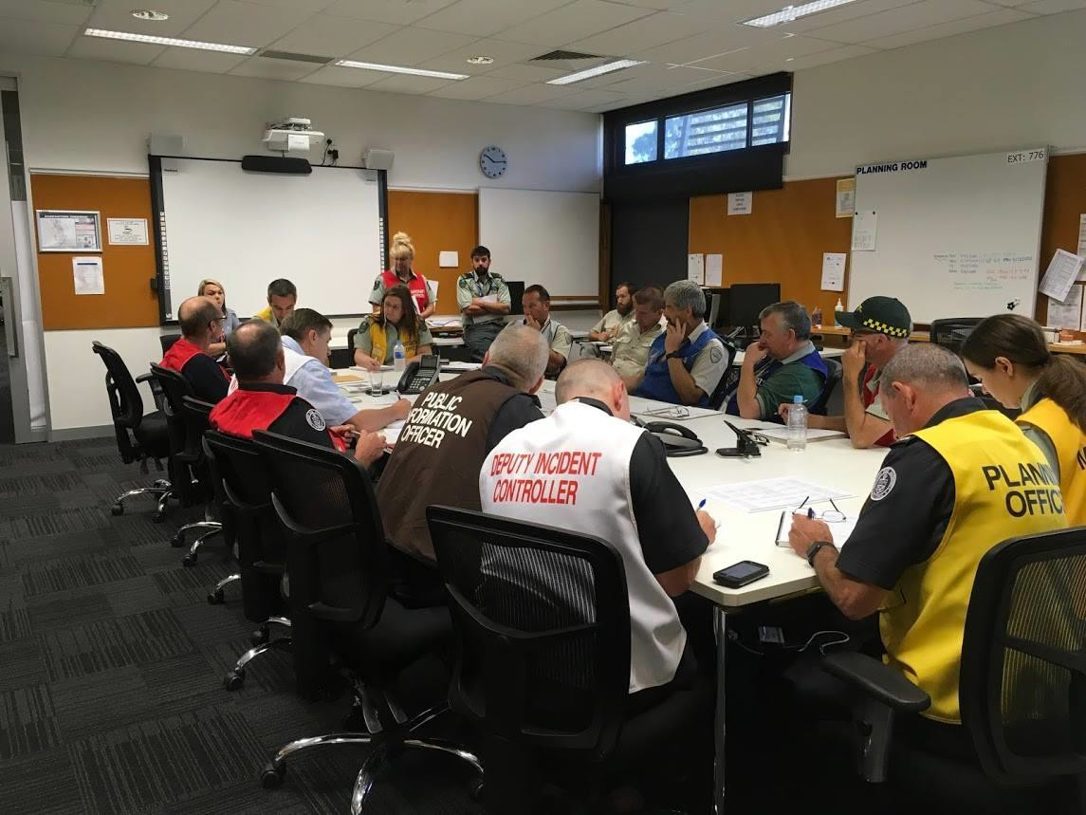

Incident Management Team Heyfield at Incident Control Centre (image courtesy DELWP)

Incident management skills and abilities

IMTs need personnel with a range of skills and knowledge to support cohesive team functioning while managing response to large and complex incidents.

Strong leadership and management contributes to ensuring incident strategies are appropriate, well- understood, and readily implemented.

Communication and team awareness are also essential in incident management. Incidents are often physically and mentally demanding. Remaining aware of team limitations and managing fatigue minimises
the risk of adverse outcomes in incident management.

Effective communication ensures information about incident objectives, strategies, safety issues and key roles and responsibilities is understood and results in appropriate action. Poor communication within the IMT creates the risk of oversights, incident management or on-ground teams being unprepared for action, or action that is not timely or appropriate.

Skills in leadership and management are developed alongside technical knowledge of hazards. Technical knowledge ensures that incident objectives, strategies and tactics are appropriate to the hazard.

An ability to understand the local context and environment and connect with community is also important. An appreciation of local geography, hazard risks, and previous incidents can improve incident management decisions [4].

Knowledge of community profile and plans, and an ability to connect with community members is particularly relevant for ICs, who will manage and lead communication with community members before, during and after the incident [4, 9].

Developing Level 3 incident management personnel

Development of personnel for Level 3 IMT roles involves a number of steps.

Personnel are required to have achieved Level 2 incident management accreditation. Level 2 incidents are of scale and complexity that can be managed by the control agency. Level 2 accreditation is specific to the hazards for which the agency has control responsibility [10, 11].

Progression to Level 3 requires the knowledge, skills and experience to manage responses to large and complex incidents. This includes working with multiple agencies, and managing interaction with other sectors of government, and the community.

Two broad areas of capability are required:

• Technical knowledge and competence: Candidates must have gained technical competence as part of Level 2 accreditation
• Personal attributes and leadership skills: Candidate development focuses particularly on the personal and leadership attributes required to effectively perform Level 3 IMT roles [10, 11].

Personnel progressing to Level 3 generally have experience in emergency management and leadership in other areas of life, so development is tailored to individual needs [10, 11].

Development activities may include:

• further learning through courses, individual study or observation

• behavioural development through leadership learning and self-development, and actual or simulated incident management experience

• integration of knowledge and experience through personal reflection and work with a coach or mentor [10, 11].

In a multi-agency system, Level 3 incidents involve an IC from one agency directing the personnel and resources of other agencies. Common standards of management knowledge, skill and ability are essential to such a system. In Victoria, this is implemented through an assessment and recognition process common to all agencies [10, 11].

3.2 Developing a Level 3 IMT training and accreditation model

Victoria’s Level 3 IMT training and accreditation model arose from recommendations of the 2009 Victorian Bushfires Royal Commission (VBRC), and the Review of the 2010-11 Flood Warnings and Response (Victorian Floods Review) [12, 13].

Recommendations of the VBRC

A finding of the VBRC, and subsequently the Floods Review, was the need for a common approach to developing and accrediting Level 3 IMT personnel.

The VBRC addressed incident control as part of its deliberations. It noted a shortage of ICs and serious problems in selection, training and accreditation:

On 7 February not all designated level 3 ICCs were properly staffed before the outbreak of fires and not enough qualified level 3 Incident Controllers were appointed and pre-positioned. The Commission accepts that each Incident Controller appointed on 7 February worked hard and tried to satisfy onerous responsibilities, but an examination of the shortage of level 3 Incident Controllers on the day revealed serious problems in the selection, training and accreditation processes for these officers.

There are important differences between the DSE system of accreditation (which involves formal assessment of a candidate against known criteria) and the CFA system of endorsement (involving the nomination or approval of a person to perform a particular role). Since both agencies provide members for joint IMTs, it is highly desirable that there be uniformity in selection, to ensure that each Incident Controller, regardless of their agency, has a similar level of experience and competence [12].

The VBRC made several recommendations relevant to incident management. It recommended improvements in the transparency of accreditation processes for Level 3 ICs, the performance review system, and the training program for IC progression from Level 2 to Level 3 [14].

Recommendation 17 of the VBRC called for the development of a uniform accreditation process:

The Country Fire Authority and the Department of
Sustainability and Environment establish before the
2010–11 fire season:

• a uniform, objective and transparent process based on the current DSE approach for the accreditation of level 3 Incident Controllers

• a performance review system for level 3 Incident
Controllers

• a traineeship program for progression from level
2 to level 3 incident management team positions
[12].

Recommendation 18 called for the appointment of ICs to be based on experience and competence:

The Country Fire Authority and the Department of Sustainability and Environment amend their procedures to require that a suitably experienced, qualified and competent person be appointed as Incident Controller, regardless of the control agency for the fire [12].

Subsequent to the VBRC, the Victorian Floods
Review made similar findings. It found that there was:

[insufficient] incident management capability and capacity to contend with large scale or protracted emergency events [13].

The Victorian Floods Review recommended the state develop a readily available multi-agency IMT
capability for statewide deployment, and that the state ensure sector-wide familiarity and understanding of
incident management systems, primarily through training and exercising [13].
The Incident Management Team Training
Project

The state government delivered its response to the VBRC recommendations in October 2010. To address the wide range of recommendations, the government allocated to the CFA $286 million over five years for
62 projects, collectively known as the Bushfires
Program [15].

The Incident Management Team Training Project (IMTTP) was one component of the Bushfires Program. IMTTP was allocated $24.72 million to address parts of five of the 67 VBRC
recommendations relating to the management of ICCs and the training of IMT personnel [14].

The IMTTP was also to honour commitments made by CFA’s Deputy Chief Officer and DSE Assistant Chief Officer during the VBRC. These commitments were to develop common training for eight key IMT roles, and to develop a coaching and mentoring program [14].

The aim of the IMTTP was to improve the sustainability of training, and the capacity and capability of incident management personnel. It was to establish common training packages, leadership and exercising frameworks, coaching and mentoring programs, experience based learning tools, and a robust accreditation program [14].

CFA progressed the IMTTP from 2010. IMTTP encountered a range of difficulties, particularly in achieving agreement amongst responder agencies on key aspects of the training and accreditation program. Its key objective was to develop a multi-agency training calendar for 2014 [14].

Transition to Emergency Management
Victoria

The IMTTP achieved its goal with delivery of the State Incident Management Training Calendar (Training Calendar) for 2014. Initial priorities were primarily aimed at meeting the bushfire management needs of the CFA and DELWP [16].

Responsibility for training delivery lays with the CFA’s Occupational Training and Volunteerism group (OT&V). The IMTTP provided funds to OT&V to support the first stage of delivery in 2014. Transition from the IMTTP to OT&V occurred from December
2013 [16].

The State Incident Management Training Delivery Project Steering Committee was formed in May 2014 to guide the initial stages of training delivery. An evaluation of the IMTTP commissioned by the Steering Committee concluded that, amongst other things:

• IMTTP’s objective of consistent and accessible training delivery for both staff and volunteers had been partly achieved for the CFA and DSE with a bushfire focused training framework, as outlined in the IMTTP project allocation requirements

• the bushfire focus does not wholly cater for 'all hazard, all agencies' training

• sustainability of the program for the ‘all hazard, all agencies’ would require the suite of training packages be reviewed and reconfigured

• the lack of identified long-term funding to support ongoing development of the training material and its delivery

• the recent establishment of EMV with its sector leadership role meant that any business model for IMT training would need EMV to articulate its preferred model and role [16].

With formation of EMV on 1 July 2014, CFA retained ongoing responsibility for maintaining and delivering IMT training. EMV has responsibility for governance, policy and strategic direction [2, 7].

EMV formed the State-wide IMT Delivery Project (SIMTDP) to further develop and deliver IMT training from 2014 to 2016. Both CFA and EMV supported the SIMTDP with funding and staff resources. This
funding concluded in June 2016 [17].

To provide ongoing advice on IMT capability development, EMV convenes a multi-agency group, the Capability and Development Working Group. The Working Group advises the EMC, and the SCRC Capability and Response Sub-committee through its chair, EMV’s Director Capability and Response [18].

The IMT Training Steering Committee has responsibility for IMT training and comprises representatives from EMV, CFA, DELWP, MFB and VICSES [2].

Delivering incident management training calendars

Since the first common training calendar in 2014, CFA has managed delivery of training calendars in 2015 and 2016, and will continue to do so in 2017.

Training is delivered across the state to meet the needs of the majority of personnel who are located outside the Melbourne area. The 2014 Training Calendar saw the conduct of 24 different courses, with a total of 92 course offerings [16].

Training Calendars for 2015 and 2016 had around one third fewer courses than in 2014.
In 2016 and 2017 there are new courses for Intelligence Officers and Resources Officers. Around two thirds of course offerings listed in the 2017 training calendar are listed as being subject to availability of funding. While some are dependent on
demand, others require further development for which funding is uncertain [19].

Reform initiatives relevant to IMT capability and capacity

The emergency management reform process is progressing two initiatives relevant to incident management capability and capacity. These are summarised in Table 2, page 15.

The Emergency Management Capability Project (the Capability Project) is progressing under the Victorian Emergency Management Strategic Action Plan 2015–
18 (SAP) [20]. The Capability Project will define a model for state capability and capacity, including IMT
capability. Required capability will be defined by
identifying state risks and associated emergency scenarios, and the capabilities required to manage such scenarios [17, 21].

Emergency Management Performance Standards (the
Performance Standards) are progressing under section 32(1)(j) of the Act [6]. The Standards will provide the base for implementing an integrated emergency management system.
Responder agencies endorsed the Draft Performance
Standards in November 2015. However, further work is required to extend the standards to the whole emergency management sector [22].

3.3 Rostering and deploying
IMT personnel

Emergency management policies for rostering, deploying, readying and operating IMTs aim to establish:

• certainty of resource availability, and the time required to deploy them

• efficient use of the right personnel
• effective incident management performance. Rostering commits an individual to perform a role for a
defined period in the future. Agency rostering policies reflect their business requirements and workplace agreements. Rostering policies establish the way in
which workloads are distributed across personnel.

Deployment occurs when a person or team is positioned for duties. In the case of an IMT, the normal place for duty is an ICC. RCs may conduct their duties from a range of locations.

Readiness establishes a level of confidence that incident management resources can be operational within a certain time of a future incident occurring. A readiness policy may require the availability of specified personnel, or only a senior manager, such as an RC, to assemble personnel if required. Readiness may require that personnel are on-call, or deployed and positioned for duty [1].

Maintaining readiness increases certainty of the timeliness and quality of response, but consumes limited resources. Readiness policies strive to strike a balance between the cost of resources committed, and the risk of an incident occurring [1].

IMTs are workgroups whose performance is influenced by levels of common understanding and teamwork. As such, arrangements for managing Level 3 IMTs and personnel can lead to differing levels of performance [1].

Response to incidents

Emergency response is the action taken immediately before, during and in the first period after an emergency to reduce its impact and consequence [5].

Control agencies for designated hazards have responsibility for first response. In most cases the IC is the most senior member of the control agency at the scene of the incident [5]. DELWP is an exception with its ICs operating from regional or district work centres.

When an incident is or has the potential to become a major emergency, then control is transferred to a Level 3 IC supported by an IMT, invoking the state line of control [23].
In such cases, the RC appoints an IC from a list of ICs endorsed by the EMC. If a RC has not been
appointed, the State Response Controller will appoint an IC [23].

Outside periods of Level 3 IMT readiness, the IC has responsibility for assembling an IMT. In these circumstances IMT personnel may be obtained by:

• deploying personnel already on shift

• requesting personnel serve in an IMT role where they are not already on shift, or are at work but not employed in an operational role.

The control agency duty officer generally begins the process of contacting personnel for an IMT, first within the control agency, and then support agencies. A duty officer may be supported by a regional resources officer.

ICs or RCs may extend their requests outside the district and region. Where possible, IMT members are drawn from multiple agencies and include personnel with relevant local knowledge [24].

Readiness

Amongst other things, readiness arrangements provide for incident management resources to be committed before an incident occurs. State arrangements require that Level 3 IMTs are readied during the summer season to meet the potential for major bushfire [24].

This provides for the likelihood of major incidents, which demand the resources and involvement of multiple responder agencies, government organisations, municipal councils, and communities [5].

Table 2: Reform initiatives relevant to IMT capability and capacity

REFORM ASPECT | INITIATIVE | REFORM INSTRUMENT
Model for state capability and capacity | Emergency Management Capability  Project | Emergency Management Strategic Action  Plan 2015–18
Implementation of capability and capacity targets and enabling policies and processes | Emergency Management Performance  Standards | Emergency Management Act 2013 section 32(1)(j)
Source: [6, 17, 20]

The transition from single agency, to Level 3 readiness, and Level 3 incident control is shown graphically in Figure 2, below.

Outside the summer season or an expected incident such as a storm, the state does not have any other arrangements that require Level 3 IMT personnel to
be readied for duty, either positioned in an ICC, or on- call while undertaking business-as-usual duties.

RCs are rostered continuously through the summer season. However, outside this period, they are only appointed to meet incident management requirements [25].
Summer bushfire readiness arrangements are formalised in a Joint Standard Operating Procedure (JSOP) 2.03. JSOP 2.03 provides for specified ICCs in each region to have Level 3 IMTs positioned ready for incident management duty. Personnel levels are site-specific, at either base with five roles, core with
10, or full with 18 roles [24]. The locations of regional
Level 3 ICCs are shown in Figure 3, page 17.

Level 3 IMTs are to be resourced from multiple agencies. Specialist roles can be shared across IMTs if required. JSOP 2.03 also requires the reporting of personnel shortages and sharing arrangements [24].

Summer bushfire readiness for Level 3 IMTs should be distinguished from the business-as-usual functions of responder agencies. These functions remain in place throughout the year and provide for resources and personnel to be continuously available for first response to any incident [5].

Figure 2: First response, readiness and state line of control (Source: IGEM)

Within agency State line of control

DELWP

CFA
State Control

Regional Control

VICSES
Operational readiness activities

Incident Control

MFB

Operating and maintaining IMTs

Level 3 IMTs generally operate continuously under a two shift model. Personnel numbers vary from five for base level readiness, to well over 100 for a large and complex incident [26].

Personnel work under the workplace conditions of their home agency. Key conditions include:

• shift times and fatigue limits

• shift lengths

• rest periods between shifts

• rest periods between deployments.

Variations between conditions applying to personnel of different agencies must be taken into account in managing initial deployment to IMTs and their ongoing resourcing [27]. Examples of differences in key conditions are shown in Table 3, page 18.

A significant part of managing a Level 3 IMT lies in maintaining required levels of personnel resourcing.
Through an operational planning cycle, RCs maintain projections of likely environmental conditions and the IMT resources and locations needed in preparedness for risks associated with such conditions [28].

Resource requests are managed informally within the ICC district. If extending beyond the district, the State Resource Request System (SRRS) must be used in accordance with JSOP 3.09. The SRRS facilitates resourcing by logging and tracking requests and their fulfilment [29].

Requests are escalated from district, to region, and state levels, providing for consideration of priorities at each level.

Resource requests are initially made within the district and handled through the IC. Requests to regional
level are directed through the RC who manages such
requests having regard for other priorities across the region [29].

Similarly, requests beyond the region are directed by RCs to the State Response Controller. Under extreme conditions the EMC may activate interstate or international support arrangements [5, 29].

Figure 3: Victorian ICC locations (Source: adapted from [2])

Primary Incident Control Centre Incident Control Centre

Mildura

Swan Hill

Grampians
Loddon Mallee

Shepparton

Wodonga

Wangaratta

Corryong
Tallangatta

Horsham Bendigo

Hume
Ovens

Ararat Gisborne

Ballarat

Seymour

Kangaroo
Ground

Mansfield
Alexandra

Swifts Creek

Bendoc

Gippsland

Cann River

Hamilton

Barwon South West

Ferntree Gully
Woori Yallock

Erica

Bairnsdale Orbost

Heywood

Geelong Dandenong
Noojee Heyfield
Sale
Traralgon

Warnambool
Colac

North West Metro

Leongatha
Ellinbank

Yarram

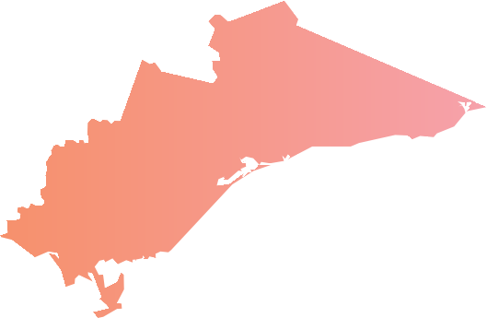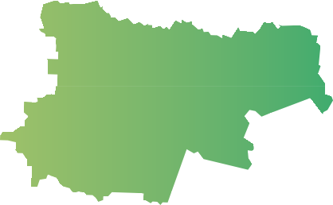
Southern Metro

Eastern Metro

Centrally maintaining incident management resources

Summer bushfire readiness arrangements provide for
Level 3 IMTs to be positioned to manage responses to incidents with the potential to become major emergencies [24]. Such teams are sometimes referred to as pre-planned [1].

To support ongoing operations, Level 3 IMTs may be assembled and deployed to other parts of the state. Regional mutual aid plans provide for agencies to plan their contributions to resourcing IMTs in other regions [30].

Other Australian states, the USA and Canada maintain centralised teams as part of their emergency readiness. Centrally-maintained, ongoing IMTs that train and work together over time are known as pre- formed teams [1].

For example, the South Australian Country Fire Service operates four centrally-maintained IMTs on a weekly rotation from October to April. This provides the state with stability and continuity to manage major incidents in the absence of significant regional capability [1].
Queensland employs Brisbane Emergency Response Teams, which are combined agency teams on permanent stand-by for deployment in case of emergency [1].

In Western Australia, a review of the 2016 Esperance
district fires recommended establishing multi‐agency, pre‐formed IMTs that could be deployed to major
incidents. The review suggested this would ease the
deployment burden of IMT resources. IMTs would draw on local knowledge, be scalable, and capable of
remote deployment [31].

Similar pre-formed IMTs are used in the USA where they are known as overhead teams [32]. The National Interagency Fire Centre (NIFC) operates overhead teams with all-hazards capability equivalent to
Level 3. The teams train and work together as ongoing organisational units. NIFC was formed to combine the firefighting resources of eight USA agencies [33].

The performance of centrally-maintained pre-formed IMTs may be better than IMTs that are assembled ad hoc. As team members train and work together over considerable periods, their familiarity leads to better communication, and better coordination. However, negative group norms and ineffective behaviours can also emerge. These behaviours can lead to unchecked assumptions and mistakes during operations [1].

The notion of centrally maintained pre-formed IMTs is discussed in more detail at Chapter 5, page 39.

Table 3: Variation in conditions applying to IMT personnel

 | CFA CAREER | DELWP | MFB | VICSES
SHIFT LENGTH (HOURS) | 12-14 | 12-14 | 10-14 | 12
MAXIMUM, OR RECOMMENDED MAXIMUM SHIFT LENGTH (HOURS) | 16 | 16 | 16 | 20 since waking
MINIMUM REST PERIOD BETWEEN SHIFTS (HOURS) | 10 | 10 | 8 | 5
SHIFT CYCLE AND REST PERIOD (DAYS) | 4 on / 4 off | 7 on / 2 off | 4 on / 4 off  Max 6 on / 2 off | 4 on / 1 off
Note: Indicative conditions for deployment, other conditions apply in most cases. Source: [27]

4 Developing IMT
capability and capacity

Incident management capability describes the skills and abilities needed to perform roles within an IMT. Capability and capacity should be planned with regard to forecasting future risk, and the emergency management resources required to manage response to emergency incidents.

Developing incident management capability involves acquiring knowledge, and learning to apply such knowledge when managing response to an incident.

Training courses, exercises, incident experience, and coaching or mentoring all contribute to the knowledge and competencies of Level 3 IMT personnel.

Ensuring that Level 3 IMT personnel achieve common standards, requires a single assessment and accreditation process. Multi-agency accreditation ensures that all agencies can have confidence in the abilities of personnel performing IMT roles.

4.1 Pathway and services for IMT capability development

The IMTTP, and subsequently EMV’s SIMTDP, developed frameworks and services to equip personnel with commonly agreed skills for managing complex and major incidents.

Since taking responsibility for IMT capability development governance and policies, EMV has established a clear accreditation framework, including roles and responsibilities of contributing organisations and individuals [10, 11].

CFA has managed delivery of training calendars in
2014, 2015 and 2016. EMV is working with agencies to make training available online to improve access
and reduce delivery costs [17].

However, once personnel have completed training, there are no sector-wide arrangements to ensure their access to the exercising, incident management and coaching necessary to achieve accreditation. Further work is required to ensure that these opportunities are available, and accessible to Level 3 IMT candidates [34].

Accreditation panels have run in 2015 and 2016, with
102 candidates having presented for accreditation by early 2016. EMV and agencies coordinate these
panels, which draw on the contributions of senior agency personnel [34].

Accreditation pathway

There is now a model for developing personnel to perform Level 3 incident management roles. This is known as the Level 3 accreditation pathway [10, 11]. However, aspects of the model are not fully implemented or agreed.

Development and accreditation of personnel to
Level 3 is undertaken to commonly agreed standards of ability and experience. As a result, setting and
implementing standards requires the involvement of agencies with a range of hazard expertise [4].

Specified arrangements for the personnel wishing to move from Level 2 to Level 3 accreditation comprise five stages:

• agencies nominate personnel for assessment by multi-agency Regional Incident Management Capability Teams. Candidates judged to meet role suitability criteria are selected for further development

• agencies have the needs of candidates for further knowledge, personal and leadership skills assessed by a psychologist, who also prepares
an individual development plan

• candidates undertake development activities, including training, and build their incident management experience through supervised exposure to exercises and incident management experience

• assessment by a multi-agency panel that includes senior operational personnel, and personnel with expertise in assessment. In some cases the panel also includes a psychologist. The panel assesses the experience, knowledge and suitability of candidates for Level 3 roles, and makes recommendations to agencies on the suitability of candidates for Level 3 accreditation
• candidates perform in the Level 3 roles, consolidating skills and experience, and submitting for reaccreditation every five years [10, 11].
This is graphically represented in Figure 4, page 20. EMV and responder agencies all contribute to the
accreditation pathway. EMV has established clear roles and responsibilities for agencies and their
candidates that wish to progress from Level 2 to
Level 3 [10, 11].

Agencies carry responsibility for developing and accrediting personnel to Level 1 and Level 2. Level 2 accreditation is hazard-specific and draws on the hazard management expertise of the control agency [5].

Candidates for Level 3 development have achieved Level 2 accreditation. Agencies have responsibility for selecting candidates for further development to
Level 3 roles, ensuring preparation of their development plans by a psychologist, and supporting
their access to opportunities for experience [10, 11].

Regional Incident Management Capability Teams are not consistently involved in selection of candidates for further development as indicated in accreditation requirements [10, 11]. Agency processes vary, however EMV has indicated that the selection process for personnel wishing to enter the Level 3
accreditation pathway is subjective, dependent on agency [2, 8].

There also remain different views as to the hazard- specificity of Level 3 accreditation for certain roles. EMV has identified this as an issue for resolution [34].

Figure 4: Level 3 incident management accreditation pathway (Source: IGEM)

Incident qualification
Accreditation pathway
Multi-agency
L3 accreditation
Maintaining
L3 accreditation

L1 L2 L3

IMT Personnel
IMT Personnel
IMT Personnel

Training Exercising
Incident management experience Exercising Incident management experience

Mentoring

Training

A comprehensive program for developing IMT personnel for a multi-agency incident management system will provide foundation training relevant to IMT roles.

The IMT training program is now well established, having been delivered in 2014, 2015 and 2016. It will also be delivered in 2017 [19].

The IMT training program addresses the foundation knowledge requirements of personnel from all agencies on pathways to Level 2 and Level 3. It also includes courses aimed at the personal and leadership development needs of candidates for Level 3 accreditation [19].

Annual calendars schedule available training for the accredited roles of IC and Operations, Planning, Public Information and Logistics Officers, as well as roles that do not require accreditation. Agencies are able to nominate personnel for training up to several weeks before training commences [19].

On behalf of EMV and other responder agencies, CFA manages the IMT training program including the contributions of senior agency personnel. These
senior agency personnel lead training programs, and the development of training materials [2, 7].
EMV, with the support of agencies, is currently developing the IMT training program to reduce delivery costs, improve access, and develop new delivery methods.

For the initial program delivered in 2014, 54 per cent of costs were for accommodation, meals, venue hire and course resources. Over 3400 nights’ accommodation were booked for 92 courses [16].

EMV intends to progressively make elements of foundation training available online to reduce or remove these costs. Online delivery will also improve access for volunteers [17].

EMV estimated in 2016 that with currently available resources, it would take five years to complete the transition to online delivery [34].

Online delivery of foundation training will also free resources for practical training. The IMT training program already uses workshops, and scenario- based exercises to help trainees apply knowledge to real-life situations. EMV is exploring other options and has recently trialled Victoria Police’s online scenario management system for training ICs [17].

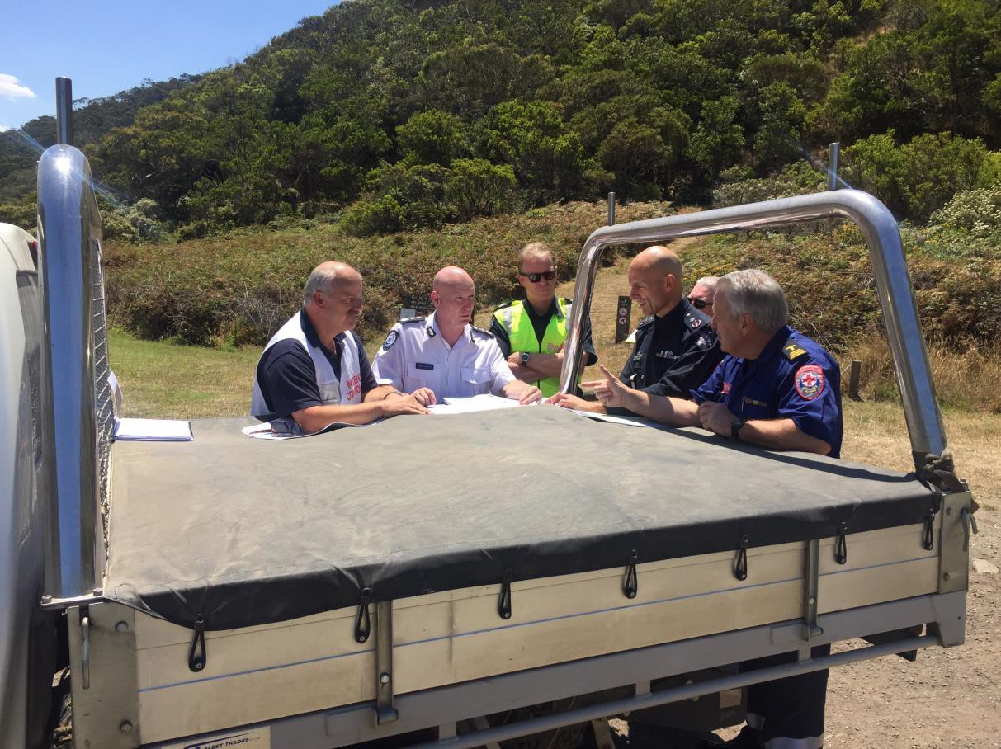

Briefing with Incident Controller and agencies (image courtesy DELWP)

Coaching and experience

For personnel progressing to Level 3 IMT accreditation, participating in multi-agency exercises and incident management, and working with an experienced incident manager, are important aspects of development.

Exercising and incident experience are also important for accredited personnel who must maintain their incident management skills to support their re- accreditation every five years.

The coaching and mentoring of an experienced incident manager helps developing personnel derive greater learning benefit from their experiences, whether gained in their agency role, in multi-agency exercising, or operational incident management.

With the supervision of experienced personnel, developing Level 3 personnel can participate in operational incident management without excessive risk.

Accreditation arrangements require agencies to ensure that Level 3 IMT candidates have a development plan, and arrangements in place to gain supervised IMT experience [10, 11]. However, EMV has identified constraints in current arrangements that affect access to coaching and supervised experience for Level 3 IMT candidates [34].

There is a lack of senior personnel available to coach or mentor candidates [34]. One indication of this is found in the EMC’s endorsement lists for 2017. The lists show 95 Level 3 ICs in transition, and 95 accredited Level 3 ICs [35].

Not all Level 3 ICs in transition require a coach or mentor. However, the number of developing personnel relative to accredited ICs illustrates the demand for incident experience and coaching.

EMV has also identified that in some areas there is a reluctance to allow supervised personnel with experience in specific hazards to perform IMT roles in real incident management situations of a different hazard type [34]. This reduces opportunities for experience, and the likelihood of developing Level 3 personnel progressing to accreditation.

Exercising

Exercising helps develop and maintain IMT capability, however exercising is constrained by a number of factors.

A training exercise is a controlled, objective-driven activity used for testing, practising or evaluating processes or capabilities. Exercising is required at incident, regional and state level to test arrangements and capability against relevant scenarios [36].

Exercise experience is also part of Level 3 IMT development. For Level 3 IMT candidates, exercising complements limited opportunities for operational incident management experience.
However, in some regions senior personnel report
that exercising is constrained by the demands of their roles, and their ability to build collaborative agency relationships at regional level.

One RC consulted for this review reported a desire to develop a regional multi-agency training and exercising calendar, but noted that preparing and running exercises often falls to the same group of heavily committed senior personnel [37].

Another RC noted the need for agencies to work together to rationalise their exercises, concentrating on multi-agency, rather than single agency exercises [37].

IGEM is shortly to establish arrangements for evaluating statewide exercising and training. This will complement EMV’s management of the exercising framework, policy, standards and support mechanisms [36].

It is also expected to contribute to improving exercise planning, conduct and review practices [38]. Evaluation should help clarify systemic factors, such as resource constraints, that may be limiting the current extent and effectiveness of exercising.

Assessment and accreditation

Accreditation is the formal validation that a candidate’s skills and abilities are at the standard needed for managing Level 3 incidents [10, 11].

The Level 3 multi-agency accreditation process is now well established, and is building a common understanding of the abilities and attributes required
of Level 3 IMT personnel regardless of home agency
[10, 34].

Multi-agency panels assess the abilities, experience and suitability of candidates for Level 3 roles. They are made up of members from at least three
responder agencies, a subject-matter expert, and may include a psychologist. The panel recommends to the
home agency that accreditation be granted, or that
candidates be required to undertake further development [10, 11].

In the case that an accreditation panel recommends a candidate for accreditation, responsibility lies with the candidate’s Chief Officer to grant accreditation. Chief Officers submit a list of all Level 3 accredited IMT personnel to the EMC each year [10, 11].

4.2 Managing and resourcing IMT capability development

Development of Level 3 IMT personnel involves both EMV and responder agencies. CFA manages and delivers the IMT training program. EMV coordinates policy making for capability frameworks, including training, exercising, and coaching or mentoring.

Agencies have responsibility for adopting the AIIMS incident management framework, nominating and managing Level 3 IMT candidates, and recognising recommendations of the multi-agency Level 3 accreditation panel.

Agencies also contribute resources for Level 3 IMT development services, including training delivery, managing and administering the training system, and contributing the time of trainers, mentors and candidates.

However, EMV and agencies need to address a range of factors that are limiting the effectiveness of investment in developing Level 3 IMT capacity.

Adoption of Australasian Inter-service
Incident Management System

To achieve a single set of Level 3 IMT capability standards, agencies must recognise and adopt the state’s AIIMS-based IMT accreditation framework.

Agencies have recognised and adopted AIIMS, but their integration of AIIMS role accreditation into their rank progression arrangements varies.

In general, agencies expect personnel to hold IMT qualifications aligned with their organisational seniority, or operational rank. Higher operational ranks require progressively higher IMT accreditation.

CFA has used the AIIMS since the 1990s. CFA policy requires that the Chief Officer endorse operational personnel for Level 3 IMT roles each year.
Nomination for endorsement is based on competencies, other endorsements, experience and
aptitude for the role [39].

DELWP (and previously as DSE) has maintained a process for assessing the skills of Level 2 ICs and Operations Officers wishing to progress to Level 3, since 2006. DELWP IMT personnel have a range of professional backgrounds, contrasting with the other responder agencies. To better manage the diversity of its personnel, DELWP intends to review its organisational pathways to Level 3 accreditation [32].

MFB’s responsibilities mean that the vast majority of its incidents are controlled from the incident location, rather than an ICC. MFB operates the Greater Alarm Response System which determines the ranks and number of personnel needed for incidents of varying severity [40].
Preparing for new risks including terrorism and major emergencies in the Metropolitan Fire District, led the MFB to commission an ICC in February 2016, and to add AIIMS incident management to the skills of its senior personnel. The first MFB personnel sought Level 3 IC accreditation in August 2016. The MFB plans for its Chief and Deputy Chief Officers to be accredited, followed by Assistant Chief Fire Officers [41].

Until recently VICSES staff and volunteers progressed through a rank structure, which assumed that organisational seniority would reflect operational
ability. VICSES has now adopted a progression framework that sets out the organisational and
operational abilities required for each rank. This integrates AIIMS accreditation, with higher operational
rank, requiring higher levels of accreditation [42, 43].

Guiding nominations to meet the state’s
capacity development needs

For the state to ensure that it is effectively developing sufficient capacity across Level 3 IMT roles, agencies must receive guidance on gaps and priorities for
Level 3 personnel across each region.

In addition, agencies will need to move towards selection criteria for Level 3 development that reflect aptitude for IMT duty, and the interest to take up such roles. Selection criteria should also manage excessive accreditation.

State level planning for Level 3 IMT personnel requirements is progressing through the Capability Project [21]. Planning arrangements based on outcomes of the Capability Project will be needed to guide agencies on shortfalls in personnel qualified for Level 3 IMT roles now and into the future.

There is a risk that without effective guidance, demand for training will not reflect the state’s future Level 3 IMT workforce needs [17]. Senior personnel report that there are current excess personnel trained or accredited for some Level 3 IMT roles, and shortages in others [17, 37].

There is also no guidance for agencies selecting personnel for Level 3 development opportunities.

Processes for access to Level 3 IMT development vary by agency. However, selection is generally
based on operational rank, and an individual’s interest in Level 3 IMT development. Agency managers validate that personnel are of appropriate seniority, have relevant experience, and are deemed suitable
for development towards Level 3 IMT roles [10, 11].

EMV notes that in some agencies selection may be influenced by criteria that do not reflect interest and potential for performance in Level 3 IMT roles [2].

Without effective guidance, demand for training may become influenced by the desire of individuals for advancement within their agencies.

This may be seen in personnel seeking qualification for several Level 3 IMT roles. Multiple accreditation that goes beyond progressive skill accumulation, or acquisition of closely related capabilities, may
increase workforce flexibility, but does not necessarily reduce gaps in capacity. Individuals can generally
only perform in one IMT role at a time. Other jurisdictions monitor training pathways to limit over-
skilling, particularly in specialist roles [1, 2, 8, 17].

As part of their management of the state’s Level 3
IMT capability and capacity, EMV and agencies should consider and agree on mechanisms to guide
agency planning and Level 3 personnel recruitment in accordance with the state’s needs [17, 34].

Progression to accreditation and maintaining accreditation

Development of Level 3 IMT personnel starts with training, but also requires several years of exercise and incident experience.

To progress through this process, agencies need to support their personnel, and provide them with appropriate development opportunities. Such support is also needed from the other agencies with which candidates can expect to work with in the IMT environment.

EMV notes that a large number of personnel receive IMT training, but that a relatively small proportion progress to accreditation [17].

As noted earlier, EMV has identified constraints in the multi-agency environment that may limit opportunities for developing Level 3 IMT personnel to progress towards accreditation [34]. Other constraints may also be affecting such personnel.

A better understanding of the barriers that candidates experience in progressing to Level 3 IMT accreditation would help EMV and agencies further improve the Level 3 accreditation pathway.

After their initial accreditation, personnel must maintain minimum levels of Level 3 IMT experience to maintain currency of skills, and achieve
reaccreditation [10, 11]. Ensuring personnel obtain such experience is an agency responsibility and maintains Level 3 capability.

Currently there is no systematic monitoring of progression from initial Level 3 IMT training to Level 3 accreditation. Current processes for reporting RCs and Level 3 ICs for EMC’s endorsement could be extended to include all personnel having commenced the Level 3 IMT accreditation pathway [35].

Monitoring personnel numbers and progress through the Level 3 pathway, would enable EMV and agencies to address excessive training, delays in progress, and weaknesses in agency or regional support arrangements. Over time this would increase the proportion of personnel commencing Level 3 development that progress to accreditation.
Resourcing the IMT accreditation pathway

Resources of EMV and responder agencies are required to support all aspects of the Level 3 IMT accreditation pathway: training, exercising, coaching and mentoring, and accreditation. Resources are currently provided as shown in Table 4 below.

Table 4: Current resource contributions to the IMT
accreditation pathway

RESOURCE | RESOURCE PROVIDED BY
Trainee’s time | Agencies
Trainer’s time | Agencies
Training delivery administration and management | CFA
Training materials development  Transition to online delivery | EMV coordination  Agencies
Training delivery infrastructure  (Learning management system) | CFA
Exercising, incident experience, coaching and mentoring | Agencies
Accreditation panels | Agencies and EMV
Source: [2, 7, 10, 17, 34]

The CFA manages and coordinates training delivery. EMV coordinates the training program including content management and development, and transition to online delivery. Agencies support these functions. The CFA has developed a learning management system to support online delivery [44].

Senior agency personnel provide their time as trainers.

Agencies provide experiential development opportunities as part of their responsibility for IMT capability. These include exercising, incident management experience, coaching and mentoring. EMV has responsibility for frameworks to guide exercising, coaching and mentoring [32, 41, 43, 45].

EMV and agencies coordinate accreditation panels, and senior agency personnel contribute time as assessors [32, 41, 43, 45].

The costs associated with Level 3 IMT training are significant. EMV estimated in 2016 the training program’s overall delivery and coordination cost at over $1 million [34]. The estimated 2016 costs of delivering two Level 3 IMT courses for the five key incident management roles are shown in Table 5, page
25.

Table 5: IMT training delivery costs

LEVEL 3 IMT ROLE | ANNUAL TRAINING DELIVERY COST ($)
Incident Controller | 48,000
Logistics Officer | 27,120
Operations Officer | 41,280
Planning Officer | 52,080
Public Information and  Warnings | 45,080
Incident Leadership | 64,160
Note: Costs based on two courses annually
Source: [34]

EMV reports that the training program does not currently have a sound funding basis, nor is there clear agreement about CFA’s ongoing role in training management [17, 34].

Upon conclusion of the IMTTP in June 2014, development and delivery of IMT training remained with CFA, while EMV had responsibility for governance, policy and strategic direction. EMV created the SIMTDP, which CFA and EMV supported with funding and staff resources for the period July
2014 to June 2016 [17].

To maintain the training program for the period July
2016 to June 2017, the EMC requested contributions from the responder agencies. The CFA, MFB, DELWP, VICSES and EMV all contributed funds [17,
32, 41, 43, 45].

Funding uncertainty remains. Of 65 course offerings on the 2017 training calendar, 41 are listed as ‘subject to funding’ [19].

EMV and CFA have a good understanding of the training program, its capacity, and the required in-kind contributions and delivery costs [17, 34]. EMV has considered a number of options for resourcing the program, including requesting additional funds from the state budget. EMV’s 2016 state budget bid was
set aside for other priorities [17].

However, Level 3 IMT capacity remains an agency responsibility. Transition to the SIMTDP and achievement of a secure model for development and delivery of IMT training will require that EMV and agencies reach agreement on a model for resourcing and funding.
Resourcing and funding arrangements for effective investment

Arrangements for contributions to resourcing and funding the IMT training program should:

• ensure the program is secure, sustainable and meets the state’s requirements for Level 3 IMT personnel

• reflect the responsibility of agencies for maintaining IMT capability

• create incentives that are consistent with increasing the proportion of personnel that commence Level 3 development subsequently achieving accreditation

• reflect the continuing interest of agencies in the training program meeting their capability development needs.

During consultations for this review, agencies confirmed they see an ongoing role in contributing resources [32, 41, 43, 45]. This is consistent with their responsibilities for maintaining capability [5, 17].

However, agencies are also concerned to ensure that the IMT program meets their capability development needs, and that the resource contributions are manageable [32, 41, 43, 45].

Resourcing arrangements should create incentives towards increasing the proportion of personnel commencing Level 3 IMT development that subsequently progress to accreditation.

Under the IMTTP, agencies did not bear the direct costs of IMT training, and so had little incentive to effectively allocate training opportunities to maximise accreditation outcomes [16].

EMV has identified that this problem remains. A significantly larger number of personnel undertake training, as compared to those that progress to accreditation [2, 17].

To improve the sustainability of the Level 3 IMT
training program:

• a funding model should be based on the full costs of the training program, including administration, materials management and development, and the time of senior personnel that deliver training

• funding contributions should reflect the fixed cost of maintaining the training program, materials and delivery capability, and variable costs associated with number of personnel undertaking training.

EMV and agencies should discuss and agree resourcing and funding needs for the Level 3 IMT training program, and seek to achieve a sustainable funding model that ensure the program is secure, and effectively meets the state’s needs for accredited personnel.

4.3 Planning and coordinating IMT capability and capacity development

A sustainable model for developing IMT personnel will be based on long-term estimates of the state’s future requirements, and on the number and age profile of currently accredited personnel.

EMV and responder agencies have prepared estimates of current and future requirements, however there is currently no comprehensive basis for planning over the time periods required to develop Level 3 IMT personnel.

A further difficulty lies in estimating current personnel numbers. While the state has good estimates of
Level 3 IC numbers, this is not the case for other roles, or for personnel close to Level 3 capability, but
not accredited.

Increasing Level 3 IMT personnel numbers will mean developing personnel from both existing professional and volunteer recruitment pools, as well as from non- traditional sources.

Coordinated planning for Level 3 IMT personnel
supply will require a framework of agreements, targets and reporting. Performance standards under section
32 of the Act are expected to provide a framework for
such planning.

Planning future IMT capacity

Effective planning and coordination of Level 3 IMT capability development needs to be based on an agreed profile of future emergency risks, and the Level 3 personnel resources required to respond to incidents that occur.

EMV, DELWP and CFA have each previously undertaken work to establish estimates of requirements for IMT personnel required to respond to bushfire incidents. This work recognises the types of factors that need to be considered in planning future Level 3 IMT capacity.

The agencies have taken the following approaches:

• EMV has used IMT summer bushfire readiness levels, together with an active incident period to estimate current IMT role requirements and shortfalls at region and state level. This provides a useful comparative benchmark for statewide
numbers and personnel development targets, but does not forecast future needs [17, 46].
• DELWP’s estimates are based on its Model of Fire Cover, and its workforce planning needs. The Model estimates human and equipment
resources required to manage response to fire by region. Estimates are based on average service levels, as well as factors such as ignition likelihood and impact [32, 47].

• CFA commissioned the Commonwealth Scientific and Industrial Research Organisation to prepare
a model of future firefighting requirements based on 2004 to 2012 deployment data. The model
estimates resource requirements for future years, allowing for variations in rate of climate change
on bushfire likelihood [48].

However, the state has not yet arrived at a single view of the numbers of IMT personnel required now and
into the future. This is the intent of the Capability Project, progressing at the time of conducting the review [21]. Planning and effective management of the state’s IMT capability is dependent on first
understanding the required IMT personnel numbers.

Estimates of required IMT personnel numbers will depend on:

• planning assumptions in the form of credible emergency scenarios

• Level 3 IMT and state line of control structures and arrangements which set the number of IMT roles required to manage response to the emergency, their skill and accreditation requirements

• the number of personnel required to sustain such roles over the period of the emergency [2, 7, 8].

Estimates should take account of anticipated changes in models of IMT and state line of control. Stakeholders have noted the impact of additional requirements, and roles added to incident management structures in recent years [7, 37].

Once decided, estimates of required IMT personnel numbers will inform the size of the overall pool of Level 3 trained and accredited personnel the state needs to maintain.

The size of this pool must take account of factors affecting the extent to which Level 3 IMT personnel can be utilised. In addition to working hours and safety requirements, these factors include:

• current arrangements in responder agencies under which Level 3 IMT duty is in addition to normal agency duties, and therefore limited by agencies’ business-as-usual [7]

• the level of discretion that personnel have to make themselves unavailable for Level 3 IMT duties [7]

• the proportion of Level 3 accredited personnel in senior agency positions that effectively preclude their involvement in IMT duty [2].

Stakeholders were not confident that the broad scope of the Capability Project would allow it to reach the level of detail required for Level 3 IMT resource planning [32, 41, 43, 45]. However, EMV is expecting the Capability Project will fulfil these requirements and will deliver relevant outputs around mid-2017.

Identifying current IMT capacity

An understanding of existing Level 3 IMT capacity is also required to estimate targets for development of future capacity. Level 3 IMT capacity comprises personnel who are:

• accredited to perform Level 3 IMT roles

• trained and experienced for non-accredited
Level 3 IMT roles.

Personnel who are trained and experienced in Level 3 roles, but yet to achieve accreditation may also contribute to overall Level 3 IMT capacity.

However, the state does not have a complete picture of the existing numbers of personnel currently available, or close to accreditation, for use across the range of Level 3 IMT roles.

EMV has made estimates of the number of IMT personnel qualified to resource Level 3 IMTs. To inform planning for Level 3 training and accreditation, EMV compared such estimates with the number of Level 3 IMT personnel needed to meet bushfire readiness requirements on a ‘code red’ day [24, 34].

Detail for the five accredited Level 3 roles is shown in
Table 6.
Difficulty in maintaining accurate records of IMT personnel numbers is common in jurisdictions with multiple responder agencies. Such records require regular updates to avoid multiple counting, and over estimation [1].

Multiple counting can arise where there are many Level 3 IMT personnel that are accredited in more than one role. Distinguishing primary and other roles,
and identifying when accreditations have lapsed helps manage this problem [1, 2, 8, 37].

EMV has good records of Level 3 ICs, ICs in transition, and RCs. With this data EMV analysed deployment of these senior personnel during 2015–16 [49]. Similarly, EMV prepared a list of Public Information Officers in 2014 to help identify qualified personnel [50].

However, EMV has identified difficulties in estimating the number of personnel that have completed most Level 3 requirements, but not achieved accreditation. Such personnel could fill certain Level 3 IMT roles, and would require relatively little additional development to achieve accreditation [34].

A mechanism to regularly monitor the number of personnel with, or progressing towards Level 3 IMT accreditation would enable better management of current capacity. The need for such a mechanism is likely to increase in the future as the number of agencies maintaining Level 3 IMT capacity increases [51].

Table 6: Requirements of JSOP 2.03 and estimated number of accredited personnel in 2016

 | MODELLED REQUIREMENT FOR JSOP 2.03 | ESTIMATED ACCREDITED PERSONNEL IN 2016
INCIDENT CONTROLLER L3 | 93 | 88
OPERATIONS OFFICER | 285 | 271
PLANNING OFFICER | 237 | 94
PUBLIC INFORMATION OFFICER | 93 | 74
LOGISTICS OFFICER | 237 | 109
Source: EMV data [34, 46, 52]

Recruitment pools for Level 3 IMT
development

Development of Level 3 IMT personnel takes many years. Personnel generally progress through lower levels of incident management qualification before considering progression to Level 3.

Demographic, workforce and lifestyle changes mean that the state needs to consider the size and viability
of the recruitment pools from which future Level 3 IMT
capability will be recruited and developed.

Responder agencies are progressing accreditation of their senior personnel, but are limited in their ability to supply larger numbers of Level 3 IMT personnel.

Not all Level 2 IMT personnel have the potential or desire to progress to Level 3. Agencies need a pool of personnel with Level 2 incident management qualifications from which to draw candidates with the interest and ability to progress to Level 3.
In both CFA and VICSES, Level 3 accreditation tends to predominate at higher rank operational levels. Representatives of CFA and VICSES both indicated that the agencies are at, or close to an upper limit on numbers of senior personnel that are accredited, or could be developed for accreditation for Level 3 IMTs [43, 45].

DELWP has considerable experience in developing IMT personnel, having operated an accreditation program prior to the 2009 Victorian Bushfires. DELWP aims to maintain 300 personnel accredited at Level 2 or Level 3 in a fire or emergency management role.

However, DELWP saw a slight decline in numbers between 2014 and 2016 [53-55].

MFB has only recently commenced the process of integrating AIIMS IMT capabilities into its rank structure and capability. As MFB’s senior ranks have considerable experience and previous training, MFB has the potential to supply more accredited Level 3
ICs [41].

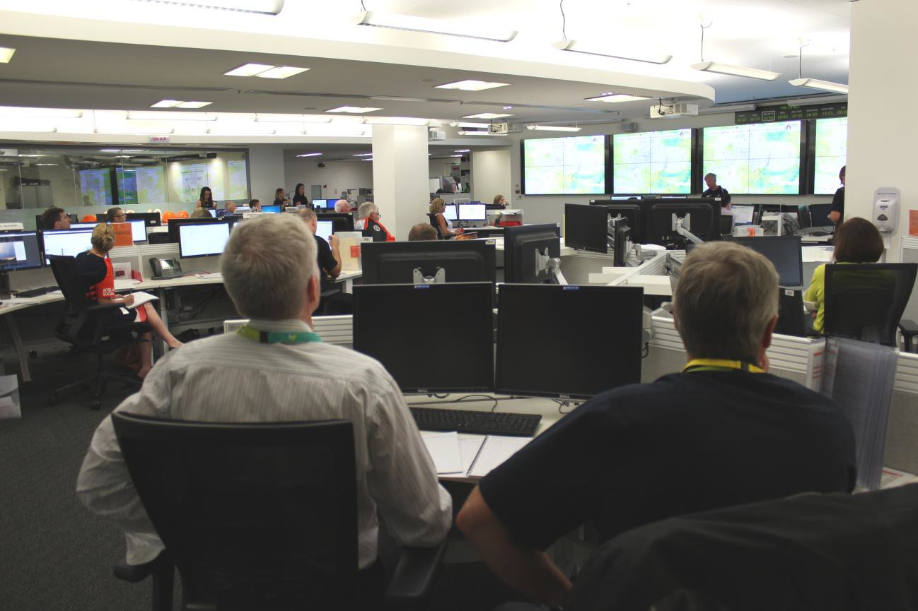

State Control Centre (image courtesy Emergency Management Victoria)

Factors affecting current and future Level 3
IMT capacity

A range of factors affect current Level 3 IMT capacity and future supply of new Level 3 capacity.

The current cohort of accredited Level 3 IMT personnel is likely to be affected by retirements in the short to medium term. A 2015–16 survey found that
44 per cent of Regional or Level 3 ICs, including those in transition, were over 55 years of age. Of this group
67 per cent were ICs [49].

Machinery of government changes, and organisational restructures have led to the departure of a significant number of DELWP’s senior Level 2 and Level 3 accredited personnel over recent years [8, 37]. This has created a gap between DELWP’s
current cohort of senior Level 3 IMT personnel, and its younger group of future leaders [37].

To address this, in some regions DELWP is engaging recently retired senior personnel for full-time RC or IMT roles, including coaching duties, during the summer season [8, 37].

Stakeholders note that Level 3 IMT roles are becoming less attractive due to their increasing complexity and the associated levels of responsibility. The greater likelihood of individuals’ performance being scrutinised through inquiry processes also makes Level 3 roles less attractive [8].

Senior stakeholders also expect that the number of volunteers working towards Level 3 IMT roles will decline due to increasing barriers to volunteer participation and the demands of Level 3 IMT development [37].

For example, to undertake Level 3 IMT development in the CFA, volunteers must be attached to a brigade and contribute to brigade activities and emergency duties. Volunteers wishing to gain Level 3 IMT qualifications must also commit time to training, exercising and meeting the required professional standards [37].

These demands occur in an environment in which lifestyle factors and reduced employer support are reducing the time volunteers are willing and able to commit to emergency management [37].

The likely decline in the number of accredited Level 3
IMT personnel, and indications that such duty is becoming less attractive, increases the need for the state to effectively plan and manage Level 3 IMT capacity.
Enlarging the recruitment pool

Responding to these factors, the SCRC is seeking to enlarge the pool from which IMT personnel could be recruited.

The SCRC’s strategy aims to increase the number of public service employees that could contribute to managing emergency events. Under initial plans, employees of departments could, with appropriate training, take up such roles [51].

In January 2016, the SCRC approved establishment of a working group to consider potential issues affecting employee participation. These include:

• opportunity costs to supplying personnel and impact on business continuity

• obligations and responsibilities in meetingdemand and supplying departments

• possible need for changes to the Public Service
Enterprise Agreement [51].

A mutual aid agreement would provide for emergency management agencies to request assistance from other government organisations [51]. Such an agreement should clarify roles and responsibilities, and terms for the request and provision of personnel.
It should support efficient operation of IMTs at incident and regional management levels.

The SCRC strategy is a prudent response to addressing gaps in emergency management capability and capacity. However, the skill requirements of Level 3 IMT duty, and time required, and limited opportunities to acquire such skills, may limit the pool of public service employees who are able to make this level of contribution.

Coordinating planning and implementation of
IMT capacity

Coordination of agency planning for Level 3 IMT personnel supply will require a framework of agreements and forward targets that recognises the ability of agencies to contribute to state capacity, and supports the long-term planning needed for Level 3
IMT capability development.

Such a framework would:

• be based on the state’s common forecast of Level 3 IMT personnel required to manage response to anticipated emergency events

• identify current Level 3 IMT personnel numbers across agencies and regions

• recognise agency capacity to supply personnel hours for Level 3 IMT duty

• encourage regional, multi-agency planning for
Level 3 IMT development.

Action is underway to establish the policy basis for decisions on capability levels, and an implementation framework of agreements and targets.

Capability levels will be established through the Emergency Management Reform Program. The Capability Project is using emergency scenarios to identify existing and desired capability of community, business and government across 21 capability areas, and the investment needed to reach desired levels [21].

Implementation of capability levels will be managed through the Emergency Management Performance Standards (Performance Standards). The Performance Standards will be a framework of targets for the performance and resource contributions of responder agencies, and possibly other agencies with emergency management responsibilities [6, 22].

Both the Capability Project and draft Performance Standards of August 2016 were under ongoing discussion in March 2017, the time of preparing this report.

Managing the transition to a long-term planning and implementation framework

The Performance Standards will help integrate efforts of responder agencies, and form an ongoing mechanism for planning and implementing Level 3
IMT personnel capacity [21, 22].

Implementation of the Performance Standards is likely to take some time. In addition to setting performance targets, the Performance Standards require agencies and EMV to resolve elements of the Level 3 IMT pathway.

The Performance Standards require that the following are achieved:

• The State Training Framework and State
Exercising Framework are adopted and applied

• A consistent and interoperable system is adopted and applied to guide the acquisition, accreditation and maintenance of capabilities

• Processes and procedures are in place that create opportunities for experience-based skill development [22].

These requirements are consistent with strengthened management of Level 3 personnel development, skills maintenance and operational management
processes. They should be addressed as part of an overall effort to improve management of the state’s Level 3 capability and capacity.

OBSERVATIONS

There is now an established accreditation pathway for Level 3 Incident Management Team (IMT) roles. Further work is needed to implement objective, multi-agency assessment of candidates, and to ensure developing personnel are able to access practical experience, including coaching and mentoring opportunities.

A long-term forecast of Level 3 IMT role and personnel requirements is needed to guide recruitment of Level 3 IMT candidates, and investment in their training and development.

Monitoring the progress of developing Level 3 personnel would help EMV and agencies identify and resolve barriers in the pathway to accreditation.

A resourcing model for the Level 3 accreditation pathway should be sustainable, reflect the responsibility of agencies for IMT capability, and maximise the proportion of new candidates that achieve accreditation.

Responder agencies are limited in their ability to supply larger numbers of Level 3 IMT personnel. To address this, the SCRC is seeking to broaden the recruitment pool to the wider public service.

Coordination of agency planning for Level 3 IMT personnel supply will require a framework of agreements and targets that recognises varying agency capability and capacity, and supports long-term agency planning for development of Level 3 IMT capability.

RECOMMENDATION 1

The Inspector-General for Emergency Management recommends that the Emergency Management Commissioner, with support from Emergency Management Victoria and in collaboration with relevant agencies, continue to ensure the effectiveness and sustainability of the state’s incident management capability and capacity.

Arrangements for developing and managing Incident Management Team (IMT) capability and capacity should:

• be based on an agreed long-term forecast of
IMT role and personnel requirements

• guide agencies in their organisational incident management capability planning

• identify, develop, monitor and support the progression of appropriate candidates through a common incident management accreditation pathway

• be supported by sustainable and efficient resourcing and funding (see Recommendation
2)

• monitor the utilisation of qualified and accredited personnel to improve multi-agency operating policies and practices

• continue to improve the efficiency and effectiveness of IMT and line of control structures, having regard for the feasibility, costs, and benefits of alternative models, such as pre-formed IMTs.

32
5 Operating an IMT

An IMT is formed when an incident cannot be controlled from the field, and the IC requires additional assistance. IMTs may be formed for AIIMS Level 2 or Level 3 incidents, or incidents that have the potential
to become Level 3 incidents.

Level 3 incidents require additional incident management resources, involve more than one agency, and invoke control from state level.

The heightened risk of bushfires demands that
Level 3 IMTs are readied during the summer season. Readiness reduces incident management response
times. ICs and IMTs can rapidly assess risks, strengthen first response, and implement public safety actions.

There is support for use of centralised IMT capacity as part of readiness arrangements. Centralised IMT capacity could improve the efficiency with which IMT resources are managed, and strengthen existing readiness and response capacity.

5.1 Resourcing an IMT

Readiness arrangements provide for resources to be committed in accordance with incident risk, amongst other things.

Current readiness arrangements for Level 3 IMTs only require they be deployed to ICCs during the summer season. At other times, business-as-usual operations provide for agencies to escalate emergency incidents to the state line of control, should that be necessary.

Summer bushfire readiness requires that Level 3 personnel be rostered. However, there is no rostering for other seasons and for other hazards. During these periods assembling a Level 3 IMT can be difficult.

Maintaining IMTs with the personnel resources needed can place significant demands on control agencies and accredited Level 3 IMT personnel in each region, particularly during protracted incidents.

Rostering and readiness

Rostering aims to commit an individual to perform a role for a defined period in the future. In an ‘all hazards, all agencies’ environment, joint rostering should reflect the responsibilities of agencies, and agreement on their level of contribution to managing response to different types of hazard.

Rostering should ensure the necessary timeframe for IMT activation can be met once an emergency incident occurs. Rostering policies should reflect the level of readiness necessary to manage response to hazards according to their likelihood at different times of the year.

Level 3 readiness arrangements currently only apply during the summer season, and for bushfire [24]. In addition, RCs are only rostered during the summer season. This ensures both regional and incident control are readied for rapid activation.

Senior agency personnel are rostered to the role of RC throughout the season. Rosters are generally established through cooperative relations between agencies and provide for RC responsibilities to be shared across agencies and personnel [37].

Incident management personnel are rostered and deployed to Level 3 ICCs across each region, ready to take up incident management immediately if a bushfire incident is escalated to the state line of control as a major emergency. These requirements are set out in JSOP 2.03 [24].

Outside the summer season, there is no requirement for heightened readiness of RCs or Level 3 IMTs. These resources must be assembled in response to emerging incident risk, or actual incident [5].

During this period business-as-usual operations provide for agencies to escalate the management of incident response if required [5]. In the event of a Level 3 incident the RC has responsibility for establishing an IMT. The State Response Controller may also play a role [23].

Most non-bushfire hazards with potential to escalate to Level 3 incidents, or major emergencies, are either not predictable, such as earthquake, or progress slowly enough to allow deployment of RCs and IMTs, such as floods [5].

However, in the absence of readiness arrangements, there are no rosters for Level 3 IMT duty. Level 3 IMT personnel must be assembled ad hoc. RCs, ICs, and Duty Officers are all involved in contacting agencies and personnel to ascertain their availability for duty.

Rostering in the multi-agency environment

The extent of multi-agency rostering for Level 3 IMTs is limited by differences between workplace conditions, and the administrative costs of rostering across agencies.
Agencies currently prepare rosters for their own IMT personnel, with local arrangements providing for multi- agency rostering during the summer season. For example, DELWP works closely with CFA in some regions, and maintains places for CFA personnel in its rosters [32, 37].

However, RCs note that multi-agency rostering is resource intensive, as there is no visibility of available personnel across the agencies [37].

Rostering for IMTs is complicated by differences in employment conditions, a key example being CFA’s four-day and DELWP’s seven-day shift periods [37].

Effective rostering relies on personnel being available at the times for which they are rostered. Anecdotal evidence suggests roster effectiveness varies across agencies. When personnel are unavailable, ad hoc requests to fill roles increase the time and cost needed to establish the IMT [37].

Bushfire readiness procedures

Bushfire readiness arrangements are now well established.

JSOP 02.03 Incident Management Team Readiness Arrangements – Bushfire sets out requirements and guides RCs on pre-positioning IMTs for summer bushfire readiness. JSOP 2.03 applies only to bushfires, and only for the summer season [24].

JSOP 2.03 provides for risk-based resourcing, with specific Level 3 ICCs resourced at one of three levels: base, core and full, with respectively 5, 10 and 18 positions. The level of resourcing, and requirement for deployment to an ICC, reflects both the likelihood of bushfire, and speed at which bushfire incidents escalate [24].

JSOP 2.03 also recognises that bushfire risk varies across the season, and can be predicted with some level of confidence. RCs have discretion to take account of state and regional risk profiles. Areas for discretion include ICC location, ICC footprint, clusters and the primary ICC for each cluster, priority locations and IMT resourcing guidelines [24].

RCs have some flexibility in how they manage IMT resources. JSOP 2.03 specifies minimum resourcing levels, availability of specialist roles, and local knowledge. However, RCs are able to manage for sustainability, and share certain specialist roles across IMTs [24].

Bushfire readiness procedures provide areas of flexibility and discretion, while increasing confidence that Level 3 IMT resources will be immediately available for a major, or fast developing incident.

Operating and maintaining IMTs

Incident management arrangements include tiered mechanisms that allow RCs to exercise discretion in the use of IMT resources, and options to obtain further resources to meet needs arising over long- running incidents.

RCs use a range of means to manage IMTs across a region when personnel numbers are limited. These include:

• expanding the footprint managed by a single IMT

• using an IMT to manage more than one incident

• reducing the number of roles in the IMT

• placing Level 2 accredited personnel in roles appropriate to lower levels of qualification [37].

These strategies are represented in Figure 5, page
35.

While RCs have significant discretion to match regional resources with the incidents under management, they may require assistance from other regions, or other states.

Obtaining additional IMT resources

Established processes help ICs supplement or fill
gaps in Level 3 IMTs, or obtain resources for alternate shifts during a protracted event.

The IC is responsible for requesting resources necessary for response to the event or for adapting tasks to fit the available personnel [29].

If unable to find personnel locally, ICs pass requests to their RC. RCs locate available personnel within the region through agency commanders, and prioritise their allocation according to incident management requirements [29].

Where personnel are not available within the region, or in the case of first attack through inter-regional arrangements, a request is made through the state
line of control to the State Controller. This provides for regions to augment regional incident teams, or IMT personnel, with personnel from other parts of the state [27, 29].

If the request remains unfulfilled it is escalated to the EMC. If necessary the EMC will request resources from other Australian states, or internationally [5, 56].
Arrangements between neighbouring regions are a means for RCs to meet incident management demands for bushfire first attack. For example, the Grampians and Loddon Mallee regions have a relationship that provides for one to assist the other. Fire behaviour is similar in the two regions, meaning that management experience is relevant to both [37].

5.2 Effectiveness of regional IMT capability and capacity

Senior agency personnel consistently report shortages of accredited personnel for Level 3 IMT roles.

However, a number of factors limit the proportion of
Level 3 IMT capacity that is available for duty.

Practices for allocating Level 3 IMT duties across accredited personnel are unclear. Outside the
summer season, assembling personnel for IMT duty is not driven by readiness requirements, or guided by work allocation policies.

Current practices may limit the extent to which accredited personnel are able to maintain their skills and developing personnel are able to prepare for accreditation.

Senior agency personnel play an important role in managing and developing IMT capability, as well as the inter-agency relationships needed to support such development. However, there are a range of
pressures on senior personnel that are constraining such activity.

Figure 5: Practices for managing IMT resources for multiple incidents (Source: IGEM)

Adapting to meet resource limits at incident level

Reducing the size of IMT

Expanding ICC
footprint
Managing multiple incidents from one ICC

Utilising Level
2 IMT personnel
Requesting resources from other regions

Requesting resources from interstate and/or overseas

Efficiency and utilisation of Level 3 IMT
capability

Service delivery and workplace factors influence the efficiency of the state’s Level 3 IMT capability, and utilisation of capacity.

Factors that have increased the number of Level 3
IMT personnel required to maintain emergency management services are:

• recent increases in the number of roles, shifts and personnel required to manage the response to a major emergency, and operate the state line of control [7]

• summer arrangements that see CFA and DELWP contributing to readiness of Level 3 IMTs in the state line of control, while at the same time operating agency IMTs at their own work centres and district offices [17].

Utilisation of Level 3 IMT capacity is affected by:

• workplace arrangements in some agencies under which personnel have significant discretion as to whether or not to make themselves available for IMT duty [2]

• barriers to personnel with different experience levels, or hazard background contributing to Level 3 IMTs [37].

Senior personnel report that in some circumstances, the pool of Level 3 personnel needed to fill one IMT position may be as large as ten [45].
These factors create strain in responder agencies, drive administrative costs associated with assembling and operating IMTs, limit the distribution of workloads, and limit opportunities for Level 3 IMT personnel to gain development experience.

Managing IMTs in the face of personnel shortages and inefficiencies in capacity

All RCs consulted for this review stated there is a shortage of IMT personnel and Level 3 ICs [37]. This reflects the limited number of accredited personnel in some regions, as well as the rates of Level 3 IMT personnel available at any time to perform IMT duties.

Shortages in Level 3 IMT personnel, or personnel available for duty, can become more apparent outside the summer bushfire readiness period, when incidents extend over long periods, or when several incidents need to be managed at the same time.

One RC consulted for this review noted the difficulty
of getting resources above core IMT level, or for more than three of the region’s four IMTs. Another noted that one fully-staffed IMT consumes the majority of
the region’s IMT personnel [37].

As RCs seek additional personnel, those already committed to one IMT may be directed to another, resulting in a ‘domino effect’, as personnel move to fill vacated roles [37].

Standing IMTs in readiness affects the available resources once incidents occur. Days spent in readiness count towards fatigue limits, reducing the time that personnel can work once an incident commences [27]. Readiness relies heavily on career personnel, as volunteers generally do not make themselves available until an emergency event occurs [2].

To form-up shift teams, RCs need to manage differing workplace conditions, including shift lengths, fatigue limits and consecutive shifts. Volunteers are often unable to commit more than a few days at a time. This means that an IMT role may be occupied by several individuals over successive shifts [27, 37].

Difficulties in holding one group of personnel together across successive shifts can reduce the effectiveness of a Level 3 IMT. Some RCs try to keep shift teams together to maintain their performance and effectiveness [1, 37].

If a control agency cannot obtain suitable personnel, or gain other agencies’ support, then significant demands are placed on individuals. Such demands can push personnel to work beyond safe limits, and create risks for emergency response personnel and the community [37].

Barriers to sharing IMT workloads

ICs and RCs consistently report difficulty obtaining sufficient IMT personnel. However, there are also a number of practice-related barriers to sharing IMT workloads across accredited personnel.

Limited numbers of available personnel, together with the need to establish IMTs at short notice means that accredited personnel who are known to be experienced and generally available are more likely to be contacted and commit to IMT duty than others [37].

There are differing views on the hazard specificity of Level 3 accreditation for the five accredited IMT roles [7, 34]. Some senior personnel report occasions when their agencies’ capabilities were not recognised by a designated control agency [34, 37]. Resolving this barrier to integration of agency IMT capacity would increase flexibility with which ICCs are managed.

A related issue concerns the difficulty reported by non-fire agencies in obtaining the support of fire agencies to resource Level 3 IMTs. For the fire agencies, annual work-plans revolve around the summer workload. Outside this, personnel schedule leave, exercises are held, and projects take priority [37].
Conversely, EMV notes that fire agencies are called
on to support the bulk of IMT deployments, regardless of hazard. These factors challenge the ability of fire and non-fire agencies to meet demands of major
emergencies [2].

When there are many instances of personnel becoming unavailable at times for which they are rostered, RCs, ICs and Duty Officers are forced to approach others. Time pressures, and the absence of policies for allocating work across personnel, are
likely to contribute to a narrowing of the Level 3 IMT
personnel approached and utilised [17, 37].

Senior personnel also point to an informal hierarchy that influences personnel who are approached to perform IMT duty. Certain personnel known for their skill, reliability and interest in major incident work, are more likely to be called for duty. This limits the opportunities for other personnel to gain incident experience [17].

These factors limit the flexibility of Level 3 IMT capacity, and limit the access of developing or accredited Level 3 personnel to the IMT experience needed to achieve or maintain accreditation.

Improved data on deployment of Level 3 IMT personnel would enable agencies and EMV to better understand patterns of workload sharing and multi- agency resourcing, and the reasons for such patterns.

Improving data on utilisation of Level 3 IMT
personnel and multi-agency resourcing

Strategies for increasing the effectiveness of Level 3
IMT capacity will require that EMV and agencies identify patterns of personnel deployment, and IMT
composition. Such understanding would help EMV and agencies improve multi-agency operating policies, processes, and practices.

Deployment to an IMT is an agency responsibility. Agencies retain deployment data to manage penalties and overtime payments associated with IMT work. However, consistent data on the utilisation of Level 3
IMT personnel has not been centrally available [32,
45].

EMV is facilitating improvements in this area. In June
2016, EMV reported data on deployment of RCs and
Level 3 ICs, and their contributions to exercising, and coaching or mentoring [49].

Further development has occurred in response to a recommendation of IGEM’s Review of the initial response to the 2015 Wye River – Jamieson Track fire to improve IMT resource tracking [9].

For the 2016-17 summer season EMV has trialled the use of a DELWP system ‘IRIS’ to track the utilisation
of IMT personnel during all complex or longer duration
Level 2, and all Level 3 incidents [32].

DELWP uses IRIS to track and deploy individuals, teams and taskforces. IRIS helps monitor resources deployed and in reserve, manage fatigue levels across a workforce, recognise deployments, and manage personnel payments [17].

IRIS data will help EMV and agencies identify patterns of deployment and utilisation of IMT personnel across IMT roles, incidents, regions and agencies. This
should contribute to a better understanding of the factors limiting IMT resourcing and multi-agency operation.

To improve strategies for increasing the effectiveness of Level 3 IMT capacity, EMV and agencies should regularly assess Level 3 personnel utilisation rates, and Level 3 IMT composition by agency [57, 58].

5.3 Coordinating IMT
capability

The continual review and improvement of operational policies and processes is a necessary part of progressing integrated operation of sector agencies. An important subject for review is the effect of operational policies and processes on developing and maintaining IMT capability.

Operational review and improvement relies on EMV and agencies. EMV undertakes operational reviews each year, and facilitates change by engaging with agency leaders.

Regional agency leaders implement changes to operational policies, but report increasing difficulty managing this work while fulfilling their agency responsibilities, contributing to state level duties, and maintaining their Level 3 IMT personnel.

Agencies are also responsible for working with their counterparts to support regional capability development, and multi-agency cooperation. This includes developing and maintaining Level 3 IMT capability.

Operational policies and practices influence how IMT capability is managed and developed. Some senior personnel note that alternate models for managing Level 3 IMT capability could improve readiness,
reduce the cost associated with assembling IMTs, and better maintain Level 3 IMT capability.

Regional leaders supporting IMT
development

Regions are a key element of a multi-agency structure for managing operations, and the regional leaders of responder agencies play a central role in managing
the development of multi-agency incident
management capability.
As senior leaders, RCs have a strong interest in the ongoing development of personnel, and in the strategies and activities that support such development [37].

In the case of Level 3 IMT personnel, this includes selecting appropriate personnel, and providing exercising, incident experience, and coaching or mentoring [10, 11].

Agency relationships support collaboration for developing personnel, particularly through regional committees [59]. Collaboration should support the medium and long-term planning needed to develop regional capability and capacity.

Supporting regional IMT capability development strategies

RCs report variations in the extent and effectiveness of agency relationships and strategies [37]. This may contribute to variation in the support available to developing Level 3 personnel, and their access to exercising, operational incident management experience, and coaching or mentoring [34].

In a number of regions, DELWP and CFA work closely to support developing Level 3 IMT personnel. Together the agencies identify personnel with potential for Level 3 accreditation, arrange coaching or mentoring relationships, and opportunities for incident management experience [37].

Regions are able to establish consultative structures, such as joint capability committees, to support this development work [59].

However, some RCs report that other regions have little or no coordination of this sort. While regional agency coordination is growing, it is not yet at a level sufficient to support the range of activities needed for IMT personnel development and maintenance [37].

Additional support may also help regions more effectively sustain their multi-agency capability, and IMT personnel development. Many senior regional personnel contribute significant time and effort to their various roles. However, they commonly experience difficulty balancing their agency role, with their RC or Level 3 IMT roles, and are concerned about the sustainability of current arrangements [37].

Regions have benefitted from the presence of four EMV support personnel, each supporting two regions. Initially placed to support emergency management planning, these personnel have also supported multi- agency exercises, organised pre-season briefings, and other activities [2, 17].

Such a support model may help reduce the administrative and organisational load on senior regional personnel, and enable them to better contribute their expertise and leadership to strengthening multi-agency relationships, and supporting personnel development.

Improving efficiency of readiness policies and management models

Improving the efficiency of current arrangements may offer opportunities to reduce the resource requirements of summer bushfire readiness, and incident management.

Under current arrangements:

• agencies are concerned about the impact of readiness requirements on their ability to resource Level 3 IMTs when incidents occur [32]

• DELWP has indicated it is at, or close to the limit at which it can commit IMT personnel to state functions without significant impact on its business-as-usual activities [32]

• VICSES experiences considerable difficulty resourcing Level 3 IMTs, and is heavily reliant on contributions of other agencies to sustain IMTs
for long-running incidents [43]

• several RCs consulted for this review have had difficulty attracting multi-agency contributions to Level 3 IMTs [37].
EMV devotes considerable attention to helping improve the resource efficiency of IMT readiness policies. EMV regularly reviews summer bushfire readiness arrangements, and has facilitated improved alignment between risk levels and readiness resource requirements [17, 60].

Regional Reserve IMTs are an example of a recent improvement in summer bushfire readiness. Regional Reserve IMTs were introduced in 2015 to provide certain regions with an IMT that is held on-call, or pre- positioned for duty as required [2, 24].

EMV’s post season reviews also highlight opportunities for agencies to improve their practices for managing IMT personnel [57, 58]. Introduction of the Standardised Resource Management System allows personnel to log their future availability, with the aim of reducing the cost of assembling IMTs [2,
61].

More significantly, EMV is working with responder agencies to develop an improved model for managing agency and state Level 3 IMTs during the summer season.

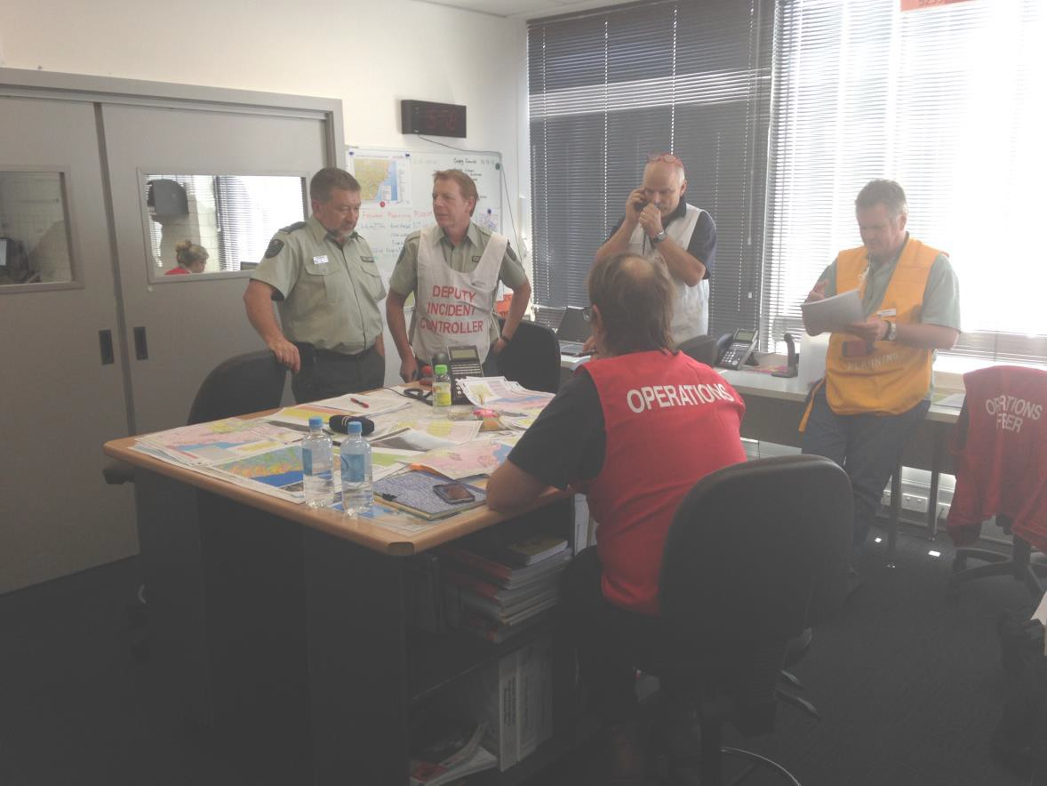

Incident Management Team discussion (image courtesy Emergency Management Victoria)

During summer, the current requirement for DELWP and CFA to contribute to Level 3 IMT readiness, while continuing to operate their own IMTs contributes to stress on both agencies [17].

EMV recently commissioned a review of ICCs and
Regional Control Centres that found:

• insufficient justification for the state’s current 42
ICCs, as well as gaps in the ICC network

• opportunities to take better account of area- specific risks when making ICC investment and location decisions

• gaps in multi-agency arrangements, systems and processes [62].

The review’s findings prompted agencies to consider the current model of parallel agency and state IMTs. EMV prepared options to help facilitate these discussions, and is now developing an improved model [2, 17, 63].

Planning alternative models for IMT
formation and mobility

While incremental improvement of existing arrangements is necessary, new models may offer opportunities for the state to achieve a substantial improvement in the effectiveness of readiness arrangements and Level 3 IMT capability.

Some senior stakeholders expressed the view that alternate models of Level 3 IMT formation and management could improve the efficiency with which IMT resources are managed, and strengthen existing readiness and response capacity [32, 37, 43, 45].

Maintaining a central group of Level 3 IMT personnel could help reduce the costs of assembling and maintaining Level 3 IMTs. A centrally-maintained group of Level 3 personnel could work as a pre- formed team, or work with a local team, providing advice or support as needed [32, 45].

Any model would require careful consideration of costs and benefits. In addition, current opportunities for improvement should also be assessed before considering alternative models.

Incident management arrangements already support mobility of complete Level 3 IMTs or groups of IMT personnel. Bushfire readiness arrangements provide for Regional Reserve IMTs as an on-call resource. Metropolitan region maintains a mobile IMT, as does Gippsland during the summer season. Regions deploy Level 3 IMTs to other parts of the state. When
necessary, the EMC assembles small teams of senior personnel to support Level 3 IMTs managing complex
events [17, 24, 37].

However, other models for mobile IMTs could increase certainty, reduce the costs of assembling personnel in response to incidents, and help develop the state’s Level 3 IMT capability.
A centrally-maintained IMT could travel at short notice to manage incidents, or to support local teams. During summer, a centralised IMT at region or state level could provide a second line of readiness. In the event of an emergency, a centralised IMT could manage response to the incident, provide alternate or night shift, or other support.

IMTs comprising personnel who regularly work and train together enjoy advantages over IMTs assembled ad hoc. Such teams can achieve high levels of performance. Queensland, South Australia and Western Australia have adopted variations on this model [1].

Centralised IMT capacity could also comprise personnel rostered on-call in their business-as-usual roles [1]. To reduce the uncertainty and costs of assembling Level 3 IMT personnel outside the
summer season, some senior personnel see the need for such on-call IMT capacity at regional level [37].

Senior leaders also note that a centrally-managed team could play a role in managing the state’s exercising program, and contribute to coaching or mentoring of developing Level 3 personnel, reducing organisation costs that currently fall to senior agency personnel [45]. By drawing together personnel from all agencies, a centralised IMT capacity could further strengthen relationships and interoperability.

However, establishing and operating a centralised
IMT capacity would have a number of costs.

Centralised IMTs would inevitably draw on the Level 3 accredited personnel from all agencies, depleting capacity required for business-as-usual activity [43].

A model requiring full-time commitment would make volunteer participation difficult. Most volunteers have commitments to employment, farms or businesses [17, 37]. Requirement for full-time commitment would effectively preclude volunteers’ involvement.

A permanent full-time capacity may require funding over and above existing employment costs, as employing agencies would most likely need to backfill positions of personnel seconded to such a group.

A centralised Level 3 IMT capacity could also erode regional IMT capability by reducing the opportunities available to regional personnel to maintain incident management skills [37]. Victoria’s regionalised system relies on a broad-based capability to manage widespread summer bushfires.

Centrally-maintained Level 3 IMTs are a feature of other states and international emergency management arrangements. However, existing arrangements, and Victoria’s regionalised system, mean that any decision to establish such a resource should be informed by a careful consideration of feasibility, costs and benefits.

OBSERVATIONS

Bushfire readiness arrangements ensure Incident Management Teams (IMTs) are ready to manage responses to incidents. For other seasons and incident types, IMTs must be assembled ad hoc, often at high administrative cost.

Reports of persistent shortages of Level 3 IMT personnel reflect limited numbers in some regions, and requirements of IMT structures and the state line of control. Low rates of availability, and barriers to sharing workloads contribute to personnel shortages.

Improved data on utilisation of Level 3 IMT personnel would help EMV and agencies improve multi-agency operating policies, processes and practices.

Support for senior personnel could help them develop and implement regional strategies for multi-agency capability, including for selection and development of Level 3 IMT personnel.

EMV and agencies are implementing measures to improve IMT personnel management, and adopt structures that reduce the personnel resources required to maintain bushfire readiness.

Centrally-maintained IMTs could augment current readiness arrangements, and reduce the costs and delays associated with assembling IMTs ad hoc. The feasibility, costs and benefits of such models should be carefully considered.
RECOMMENDATION 2

The Inspector-General for Emergency Management recommends that a sustainable funding model be developed for all levels of incident management in Victoria which:

• considers business-as-usual, agency managed response activity, and responses to major emergencies managed under the state line of control

• recognises the additional resource requirements created by plans for trained and accredited incident management personnel arising from the reform program

• accommodates personnel training and development requirements in excess of those for which responder agencies are currently funded.

Appropriately scaled and sustainable funding will enable the emergency management sector to effectively mount responses to all levels of emergency into the future.

6 Concluding remarks

This Review examined the effectiveness of incident management arrangements in Victoria. It is concerned with AIIMS Level 3 incident management for Class 1 emergencies.

There has been considerable progress in developing a sustainable Level 3 incident management program since the VBRC made recommendations on the subject in 2010.

EMV and responder agencies have all contributed to establishing the Level 3 accreditation pathway, and to maintaining the personnel resources necessary to manage Victoria’s profile of emergency incidents.

Senior personnel across the state contribute their skills, experience, and commitment to managing emergencies of all types, and to encouraging and developing the personnel who provide critical incident management functions.

However, further work is required to strengthen the effectiveness of the Level 3 IMT accreditation pathway, and the regional management of IMT resources. This task deserves timely consideration.

The Inspector-General has made two recommendations to address these issues. Several observations highlight aspects of the state’s incident management capability development program, its management, and opportunities for improvement.

7 References

[1] C. Owen, "Practices of human resource rostering and deployment of Level 3 Incident Management Teams: A
review of Australian and selected international jurisdictions for the Inspector-General for Emergency Management,"
2016.

[2] Inspector-General for Emergency Management, "Correspondence with Emergency Management Victoria March- April 2017," 2017.

[3] Emergency Management Victoria, "Emergency Management Manual Victoria," ed, 2015.

[4] Australasian Fire and Emergency Services Authorities Council Limited, Australasian Inter-services Incident
Management System., 4 ed. Melbourne: Australasian Fire and Emergency Services Authorities Council Limited,
2013.

[5] Emergency Management Victoria, "Emergency Management Manual Victoria - Part 3 State emergency response plan (Revised version 1.0)," 2016

[6] Victorian State Government, "Emergency Management Act 2013," ed, 2013.

[7] Inspector-General for Emergency Management, "Correspondence with CFA March-April 2017," 2017.

[8] Inspector-General for Emergency Management, "Correspondence with Department of Environment, Land, Water and Planning March-April 2017," 2017.

[9] Inspector-General for Emergency Management, "Review of the initial response to the 2015 Wye River – Jamieson
Track fire," State of Victoria, Melbourne, 2016.
[10] Emergency Management Victoria, "Incident Management - Accreditation Fundamentals," ed. Melbourne, 2014. [11] Emergency Management Victoria, "Incident Management - Accreditation-L3," E. M. Victoria, Ed., ed. Melbourne,
2016.

[12] Victorian Bushfires Royal Commission, "Victorian Bushfires Royal Commission Report," 2009.

[13] N. Comrie, "The Review of the 2010–11 Flood Warnings and Response," State Government of Victoria, Melbourne,
2011.

[14] PwC, "Incident Management Team Training Project (IMTTP): Major Projects Review – Phase 1 Discussion Paper,"
2013.

[15] Country Fire Authority, "Bushfires program evaluation. Learning from the past: Lessons for the future", Melbourne,
2015.

[16] MGN Consultancy, "2014 State Incident Management Training Delivery Pilot Project: Final Evaluation Report," Melbourne, 2015.

[17] Inspector-General for Emergency Management, "Minutes of meetings with Emergency Management Victoria June- November 2016," ed, 2016.

[18] Emergency Management Victoria, "Terms of reference: Capability and Development Working Group", ed.
Melbourne, 2015.

[19] Emergency Management Victoria, "Statewide incident management training calendars 2015, 2016, 2017," ed,
2015-2017.

[20] Emergency Management Victoria, "Victorian Emergency Management Strategic Action Plan 2015–18 Revised version 1.0," Emergency Management Victoria, Ed., ed. Melbourne: State Government of Victoria, 2015.

[21] Emergency Management Victoria, "Victorian Emergency Management Capability and Capacity Project," in
Submission to the SCRC Capability and Response Subcommittee, ed, 2016.

[22] Emergency Management Victoria, "Emergency Management Performance Standards: Draft August 2016," Emergency Management Victoria, Ed., ed. Melbourne, 2016.
[23] Emergency Management Victoria, "JSOP 3.15 Transfer Of Control And IMT Relocation, version 2.0," ed, 2015. [24] Emergency Management Victoria, "JSOP 2.03 Incident Management Teams Readiness Arrangements, version
10.0," ed, 2013.
[25] Emergency Management Victoria, "JSOP 3.14 Control Of Class 1 Emergencies, version 2.0," ed, 2015. [26] C. Owen, Dwyer, I., "Review of incident management teamwork and multi-agency collaboration," Bushfire
Cooperative Research Centre and University of Tasmania, Tasmania, 2009.

[27] Emergency Management Victoria, "Operational Resourcing Guidelines," ed, 2016.

[28] Emergency Management Victoria, "JSOP 3.17 Regional Strategic Plan, version 2.0," ed, 2015.

[29] Emergency Management Victoria, "JSOP 3.09 Resource Request Process, version 3.0," ed, 2015.

[30] Emergency Management Victoria, "JSOP 2.01 Local Mutual Aid Plan - Fire Agencies, version 6.0," ed. Melbourne,
2015.

[31] Western Australia Department of Fire and Emergency Services, "Major Incident Review of the Esperance district fires," 2016.

[32] Inspector-General for Emergency Management, "Minutes of meetings with Department of Environment, Land, Water and Planning June-November 2016," ed, 2016.

[33] National Interagency Fire Center. (2017, February 13). National Interagency Fire Center Homepage. Available:
www.nifc.gov

[34] Emergency Management Victoria, "IMT capability development discussion paper (EMV internal document)," ed,
2016.

[35] Emergency Management Victoria, "Emergency Management Commissioner endorsed Regional Controllers, Incident Controllers and Incident Controllers in Transition," ed. Melbourne, 2017.

[36] Emergency Management Victoria, "Exercising arrangements (EMV internal document)," ed, 2016.

[37] Inspector-General for Emergency Management, "Consultations with Regional Controllers October-November
2016," ed, 2016.

[38] Emergency Services Leadership Group, "Meeting paper 6 November 2015: Information update on state-wide training and exercising," ed, 2015.

[39] Country Fire Authority, "SOP 8.03 Incident Management Team Members – Endorsement of," ed: Country Fire
Authority, 2011.

[40] Emergency Management Victoria, Fundamentals of Emergency Management (Class 1 Emergencies), 1 ed.
Melbourne: State of Victoria, 2015.

[41] Inspector-General for Emergency Management, "Minutes of meetings with Metropolitan Fire Brigade June- November 2016," ed, 2016.

[42] Victorian State Emergency Service, "Operations Progression Framework version 1.4 (internal document)," ed,
2016.

[43] Inspector-General for Emergency Management, "Minutes of meetings with Victorian State Emergency Service
June-November 2016," ed, 2016.

[44] Emergency Management Victoria, "All Hazards Incident Management Training System (EMV internal document)," ed, 2014.

[45] Inspector-General for Emergency Management, "Minutes of meetings with Country Fire Authority June-November
2016," ed, 2016.

[46] Emergency Management Victoria, "IMT capability models (EMV internal documents)," ed, 2015.

44

[47] Department of Sustainability and Environment, "Model of Fire Cover Review," Department of Sustainability and
Environment, Ed., ed. Melbourne, 2012.

[48] Country Fire Authority, "IMT capability model (CFA internal documents)," ed, 2015.

[49] Emergency Management Victoria, "Incident and Regional Controller Capability 2015-16," ed, 2016.

[50] Inspector-General for Emergency Management, "2013-14 Fire Season Compliance Report," ed: State of Victoria,
2014.

[51] State Crisis and Resilience Council, "Policy Paper: Whole of Victorian Government Agreement for Emergency
Management Capacity and Capability," ed, 2016.

[52] Emergency Management Victoria, "L3 Accreditation Panel Records (internal document)," ed, 2017.

[53] Department of Environment Land Water and Planning, "Annual Report 2015," Department of Environment Land
Water and Planning, Ed., ed. Melbourne: State of Victoria, 2015.

[54] Department of Environment Land Water and Planning, "Annual Report 2016," Department of Environment Land
Water and Planning, Ed., ed. Melbourne: State of Victoria, 2016.

[55] Department of Treasury and Finance, "Getting it done: Victorian Budget 16-17 Budget Paper No. 3," Department of
Treasury and Finance, Ed., ed. Melbourne, : State of Victoria, 2016.

[56] Emergency Management Victoria, "Victorian Bushfire Handbook," 5.1 ed, 2016.

[57] Emergency Management Victoria, "Emergency Management Operational Review 2014-15," 2015.

[58] Emergency Management Victoria, "Emergency Management Operational Review Fire Danger Period 2013-14,"
2014.

[59] Emergency Management Victoria, "Emergency Management Manual Victoria - Part 5 State and Regional
Emergency Management Committees," ed, 2015.

[60] Emergency Management Victoria, "Weekly Chief's Meeting 14 September 2015: SOP J02.03 IMT readiness arrangements for bushfire," ed, 2015.

[61] Country Fire Authority, "Availability Tool Background Information (CFA internal document)," ed, 2016.

[62] Emergency Management Victoria, "Regional Control Centre and Incident Control Centre Investment Strategy (EMV
internal document)," ed, 2016.

[63] Emergency Management Victoria, "Meeting Paper - State Control Team Business Monday 3 April 2017. Strategic
Review of Incident Control Centres (ICC) and Regional Control Centres (RCC)," E. M. Victoria, Ed., ed. Melbourne,
2017.

This page left intentionally blank

Inspector-General for
Emergency Management

ORI.A tate overnment

